Power-Up the Business Case: Deep Dive Quantifying Multiple Benefits using JUSTIFI
Practice using JUSTIFI with the Camper Canopies Example

Training Worksheet for Session 3
10/6/2026

Company Background

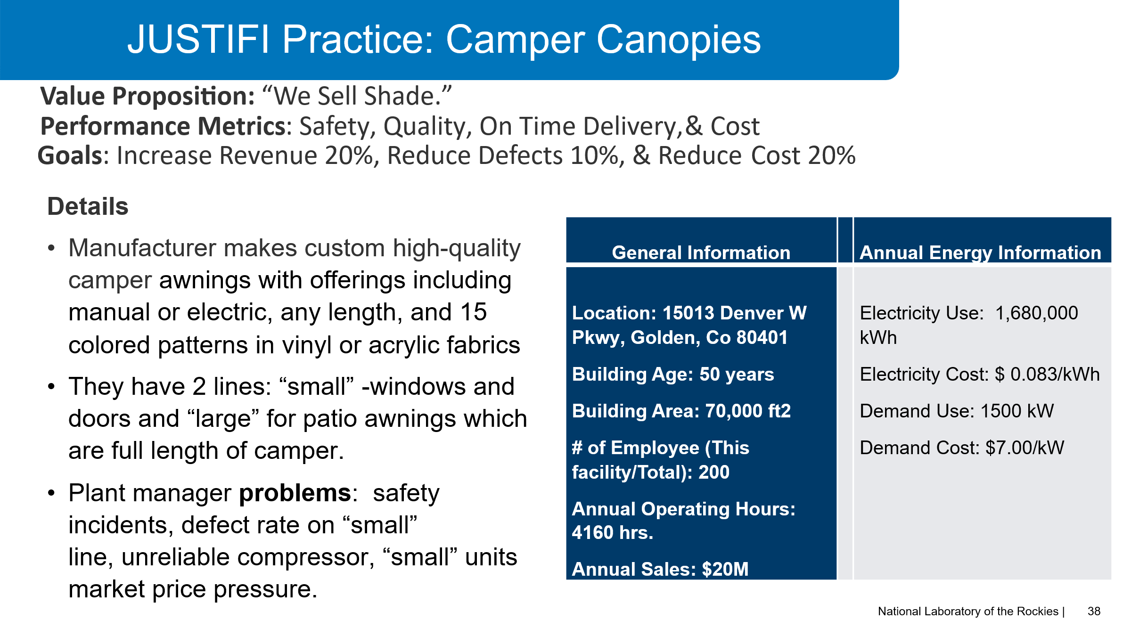

Notes from interview with Plant Manager about their compressor
- Maintenance manager says they have an end of life compressor which breaks down frequently 10-12 times per year.
- They only have one repair vendor who has “the guy” who know how to fix it. Cost $1500 each time.
- Repair parts never in stock. Parts have a long lead time. Each service visit is at least $500 in parts.
- The Small awning line uses air to move fabrics and run most of the punching equipment. They use air tools. Operators blow off debris from punches and chop saws.
- The Small awning line stops or drastically slows down frequently due to compressor problems. It probably has less than 1% impact on productivity. But when it happens the supervisors must move operators to other work streams. Based on conversation with Small Awning supervisor this is to be estimated at .5%.
- There are many air leaks. Operators use colored duct tape to patch leaks. It looks like a carnival in the plant.
- The air leaks are noisy. Operators complain. They have a hearing conservation program.
- Operators prop open the emergency exit near the compressor room because it is very hot. One time an unknown person walked into plant through the propped open emergency exit door. That caused quite a safety risk and distraction from schedule. Safety Manager later estimates 20 operators could be excluded from hearing conservation program.
- Because it was so hot, operators used too many fans, and they had a small electrical fire.
The Small Awnings supervisor believes this is worth at least $1000

Beyond Energy Cost Savings: Foundation for Multiple Benefits & JUSTIFI

Multiple benefits are operational/strategic improvements beyond energy cost savings.

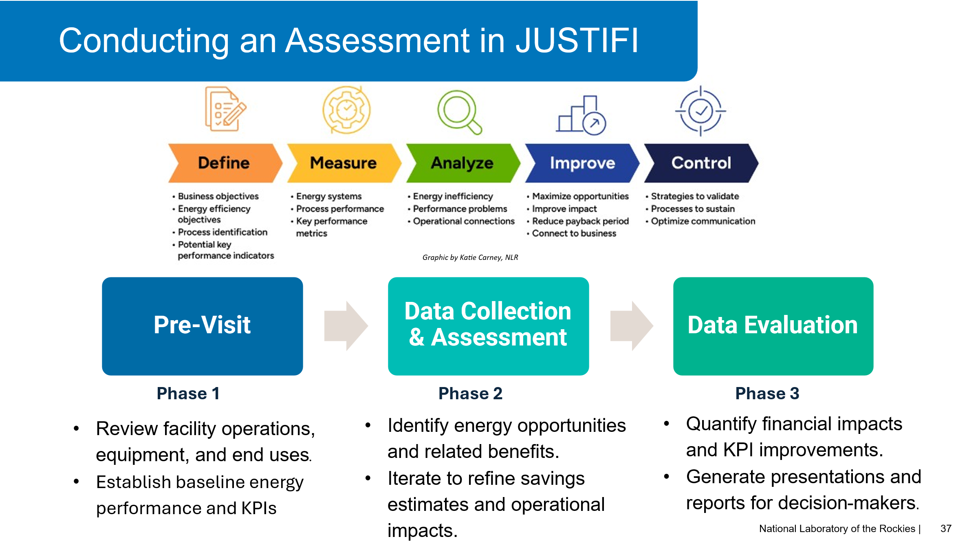

Pre-visit
Use Camper Canopies background and interview notes information to complete a Turtle Diagram Turtle Diagram Template

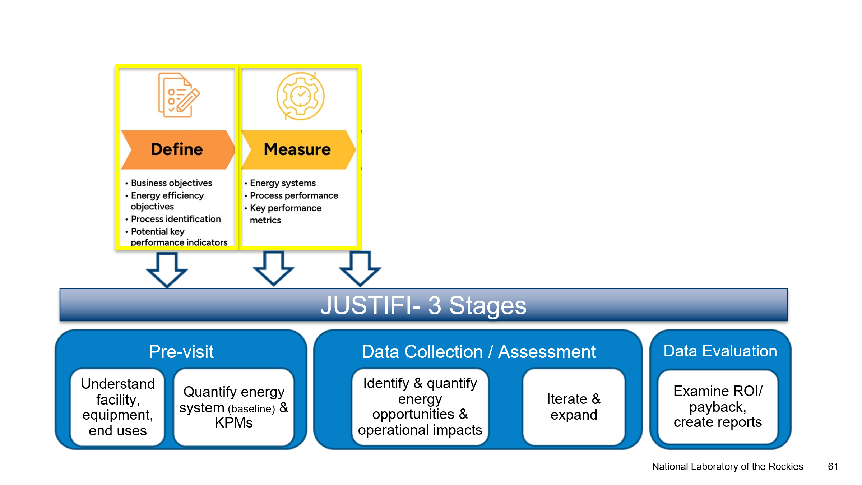

In JUSTIFI – Load Canopy Training example and work through pre-visit phase using arrow prompts at bottom of screen
- Answer or edit 2 facility questions
- Add stakeholder
- Explore KPIs/KPMs
- KPI Direct Labor Cost is calculated by total hrs. x hour wage $25/hr. Correct error in total hours which should be 4160 hrs. not 416,000 hrs.
- Engineering estimated $5000/year for their time on machine fixes resulting from compressor failures.
- (3rd Party Vendor) used for vendor service calls 10 times per year costing $1500 per visit
- Industrial System Inventory (From Turtle Diagram)
- Industrial Use Equipment- compressor is 200 hp rotary screw 26 yrs old.
- Review Take Stock questions.
- End use equipment- canopy line (small)
- Industrial System Assessment - Called industrial air system and type is compressor. Find the energy use 954,154 kWh and costs $79,290 of the total $140,000/year bill.
- 1 Assessment has been planned and added in pre visit phase work.

What is it called? _______________________________________

Data Collection

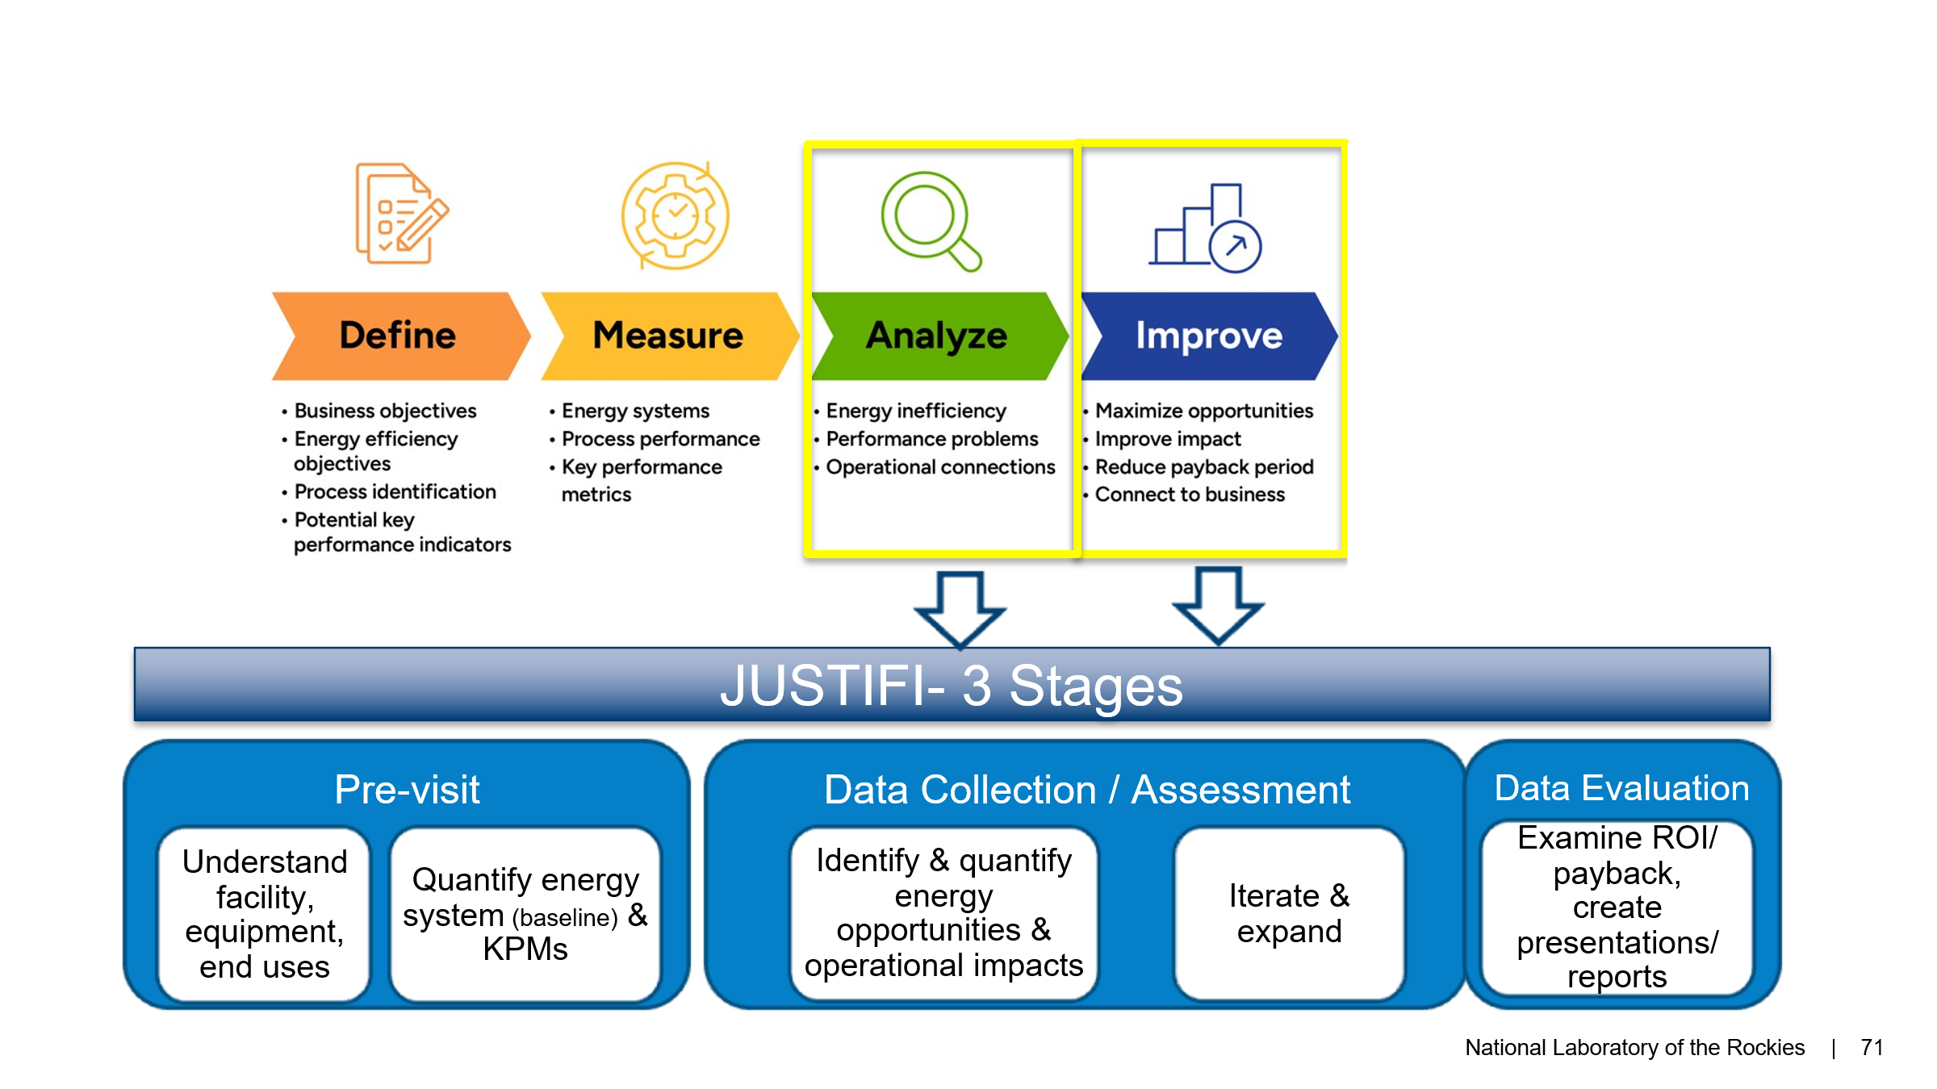

Review Better Plants Info Card and end of life equipment recommendations.

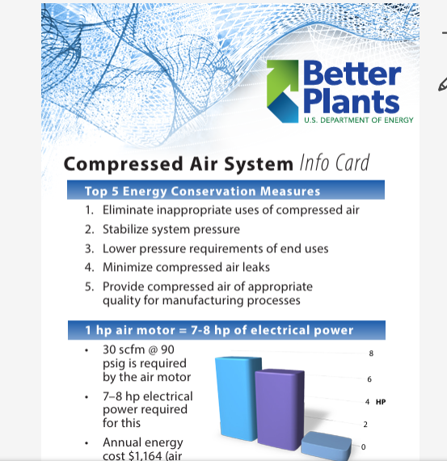

In JUSTIFI find Data Collection- Industrial System Air- Details: Compressor uses 954,159 kWh, about $80K/year.

EEMs (Energy Efficiency Measures)

- Replace with highly efficient compressor. What is the estimated implementation cost? _______

- Fix air leaks. How is $3000 implementation cost estimated? ___________________________

Complete Fishbone Diagram based on these 2 EEMs and the following interview notes:

Maintenance Manager said:
“Maintenance Labor Costs, there would be 75 less hours per year for maintenance labor on new unit. Vendor Cost Reductio, - the new PM contract would be $5,000 and wouldn’t plan for service and repair outside of this contract. $10,000 savings. Service parts costs go down too. We would spend 75% less on parts on the $5000 baseline.”

Safety Manager said:
“If these leaks are fix and noise levels are below 85 dBA as an 8-hour time-weighted average (TWA) under 29 CFR 1910.95(c) in the small awnings areas, we can pull 20 operators from the hearing conservation program. Each person costs $500/year between testing and training. Also, I wonder if we can calculate the fire prevention or risks for heat related illnesses.”

Small Awning Production Supervisor said:
“We could increase productivity by 1% in direct labor cost savings. And while workplace discomfort is not something you can easily quantify, it’s worth at least $1000 to me if people stop complaining about heat, stop propping doors open, and stop causing fires!”

Engineering Manager:
Engineering Support-Engineering said they thought there would be 75% reduction on the time and cost they spent fixing equipment impacted by old compressor.

In JUSTIFI- click through each multiple benefit added from your fishbone diagram and interviews.

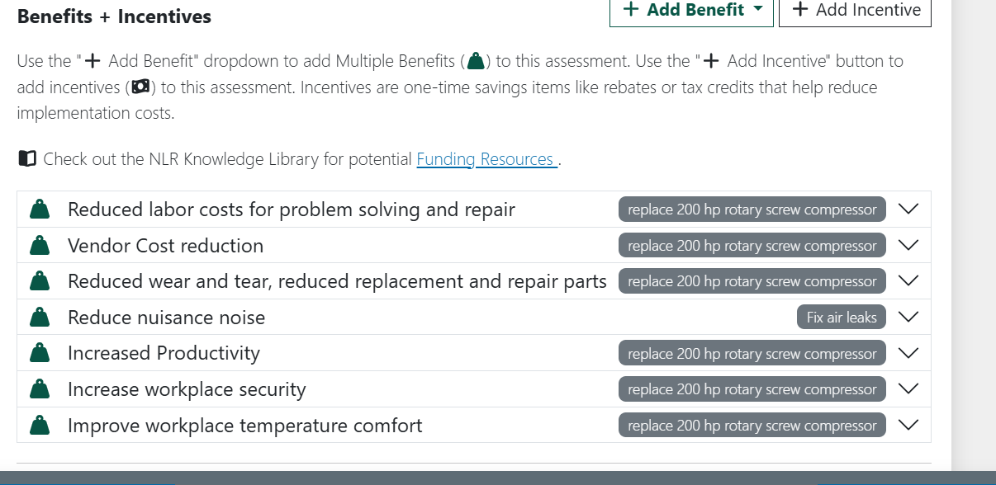

Data Evaluation

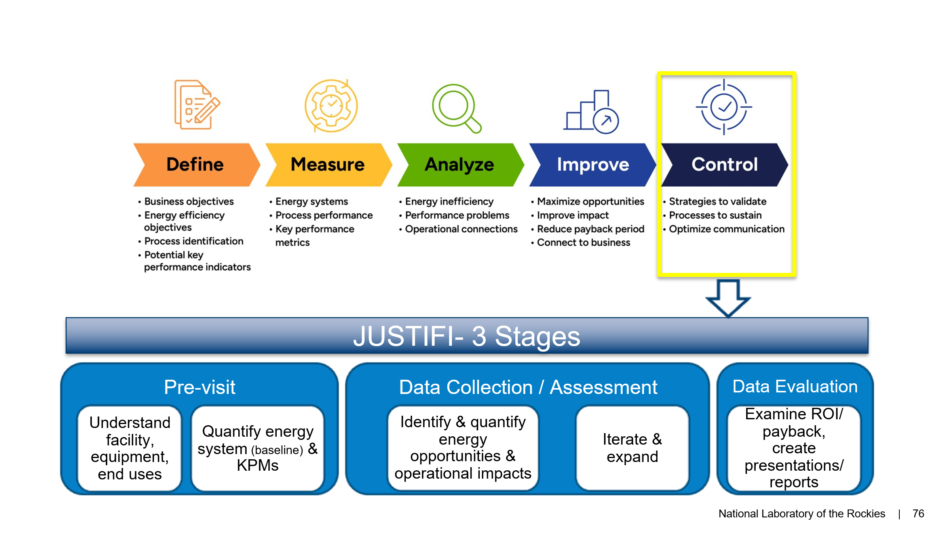

In JUSTIFI, select executive summary in Data Evaluation Summary
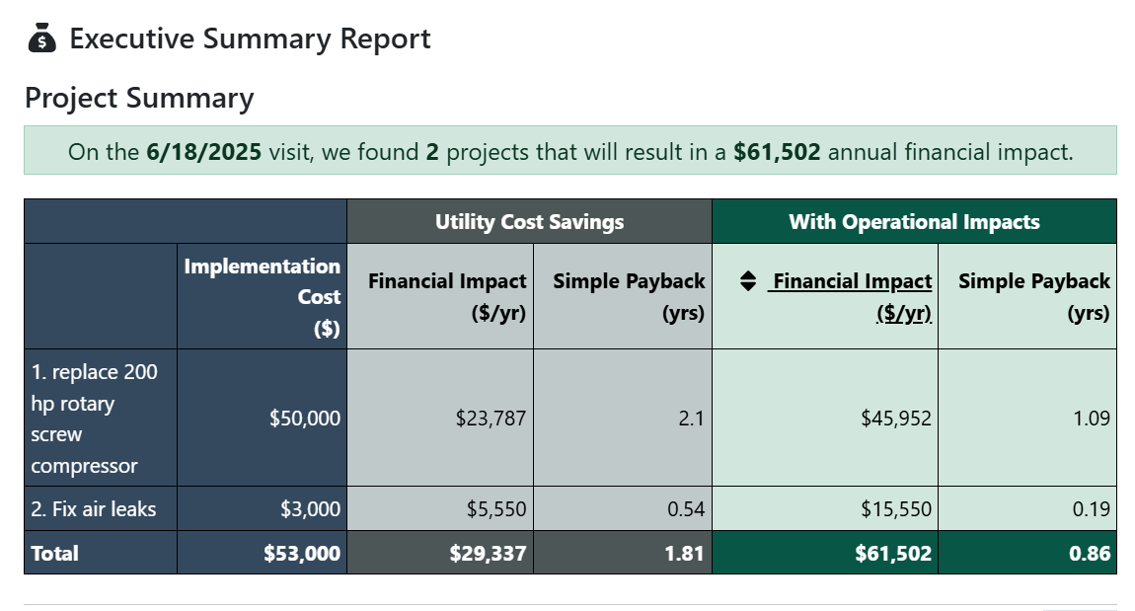

These are pretty good recommendations with less than 2 year payback. With multiple benefits, payback is under a year!

Because in real life these numbers change based on new information or feedback. Update to reflect:
- Implementation costs for new compressor were too low, now enter $75,000.
- You got information that productivity impact was estimated to be too high and should be .5%.
- Safety changed their mind. They don’t want to pull anyone out of the hearing protection program.
What is payback now with only energy cost savings and when you add in multiple benefits?

What else is needed to get this project approved?

Challenge question (Quality Benefits):

- You find out that when the compressor goes down it messes up the punch press for the small awning rail. It not only damages the current rail, but the subsequent rails holes are also not quite aligned causing assembly defects. Talk to production supervisor and quality department and add multiple benefit(s) for quality improvement achieved from installing new reliable compressor. (hint: scrap rate and rework costs)

Enter your own estimates and any data needed to add new multiple benefits.

Update JUSTIFI. What is payback now? ______________________________________________

