n

Name: _____________________________________________

Company: __________________________________________

1. Using the utility rate sheet attached to the email calculate the company’s utility bill for the data given below. Include costs for: demand, energy use, power factor penalty (if any), facility charges and taxes. The power is delivered at 13,000 volts from the utility. The rate sheet to use is attached. The tax rate is 1.5%. The meter reading date is 04/01/2023 and the Monthly FCA is 0.01785. The rate is TDMSC.

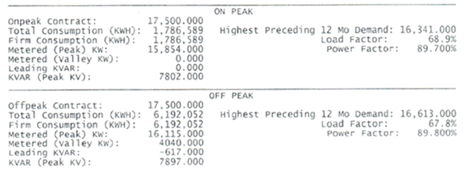

1. For the utility bill shown below record/calculate the following and illustrate on power triangles.
   1. Real kW demand for on-peak, off-peak periods
   2. The maximum demand
   3. Apparent power (kVA) for on-peak and off-peak periods
   4. Reactive power (kVAR) for on-peak and off-peak periods
   5. Power factor (%) and power factor angle in degrees for on-peak and off-peak periods
   6. Dollar cost of the power factor penalty paid ($), both lagging and leading
   7. kVAR’s of capacitors needed to correct the power factor to 95%
   8. Savings this month if the power factor had already been corrected to 95%
   9. Estimated project cost if capacitors can be installed for $60/kVAR
   10. Project simple payback if all month’s bill is exactly like this one



Solutions



