n

Name: _____________________________________________
Company: __________________________________________

- Continue to work on your pumping systems to develop potential projects. The last session of this workshop will be for the participants to present analyses of their systems with projected savings, costs, and simple paybacks.

Go the Extra Mile: If you have time work through some of the following!
Answers are included after the questions.
- Use the pump and systems from Homework #4, restated in red below. The pump below was selected for 2000 gpm at 225 feet of head. You are to investigate the operating points for this pump operating at 1500 rpm, 1000 rpm and 750 rpm for three different systems operating with a VFD for capacity control. The first system is all frictional with no static head. The second system has 30 feet of static head and the final system has 125 feet of static head. Determine the system curves in MEASUR. For Homework #5 the plant has decided they need a constant flow of 1300 gpm. Determine the following: 1) the required pump operating speed for each three systems to deliver 1300 gpm; 2) the pump efficiency at the operating point and rpm for each system providing 1300 gpm; 3) Assuming electric power costs $0.08/kWh and $14.75/kW, calculate the annual operating cost for the pump for each system. The pump operates continuously. Assume the VFD is 97% efficient. For motor efficiency use the electric motor calculator in MEASUR and the calculated pump input energy from flow, head and pump efficiency for each system. Standard water is the fluid.

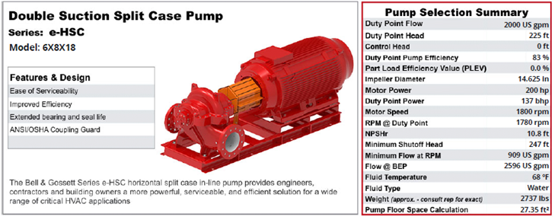

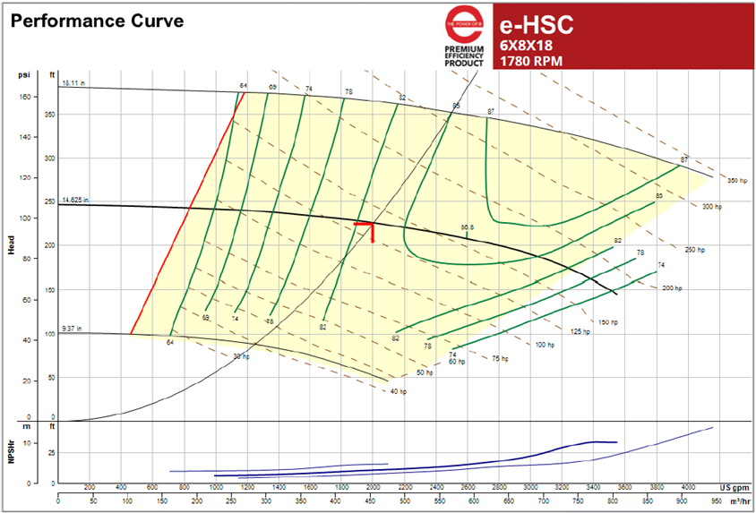

- The system below is operating with the level in the suction side tank measured to be 28 feet above the centerline on the pump. The operating pump has a suction pressure at the gauge of 5.6 psig. The pump not operating has a suction pressure of 7.8 psig on its gauge. The fittings contributing pressure loss are a tee (k = 0.9), check valve (k = 2.0), gate valve wide open (k = 0.15). The pipe and all components are in 10” nominal schedule 40 pipe (ID = 10.02”). Using the measured pressures estimate the flow rate from one operating pump.

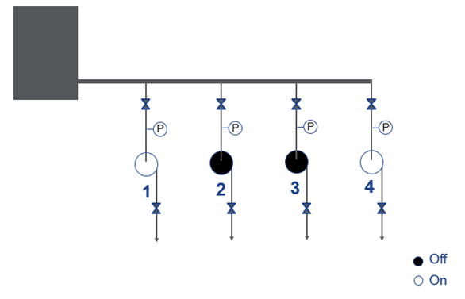

- A manufacturing plant has a pumping system that operates continuously running three 100 hp pumps in parallel. The discharge header pressure was logged for one day and is shown below. Some of the plant operations shut down on the third shift. The plot below shows the header pressure rising to 95 psig for over 6 hours at night. By operating fewer pumps or adding VFDs for pump flow control it would be possible to drop the header pressure to 70 psig for at least 6 hours per day, 365 days per year. The daytime flow rate is estimated to be 5800 gpm and the required nighttime flow rate drops to 4350 for the 6-hour period. The specific gravity of the fluid pumped is 0.93. The suction pressure gauge reads 10 psig. There is no elevation change between the suction and header pressure gauges. Assume the pump efficiency is constant at 75%. There are no loss coefficients to consider. The cost of electricity is a flat rate of $0.07/kW. Calculate the potential savings from lowering the header pressure from 95 psig to 70 psig for 6-hours per night for 365 days per year.

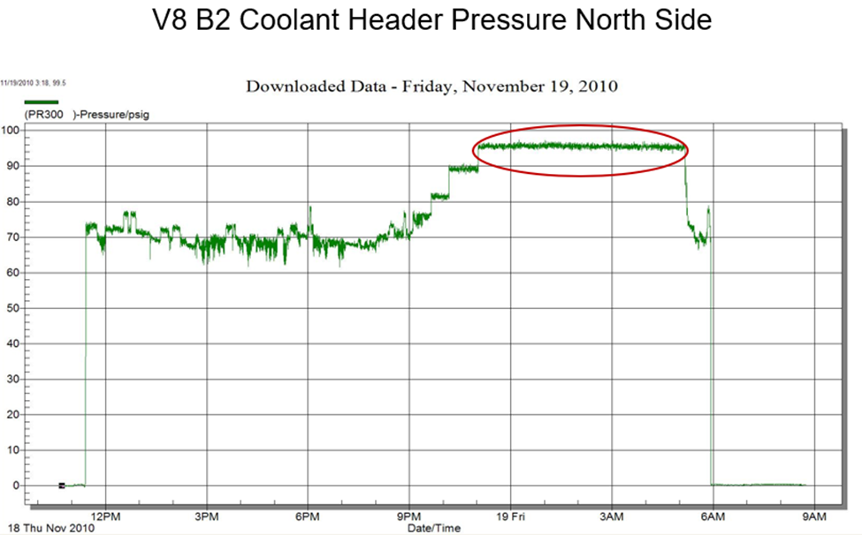

Answers
- Answer
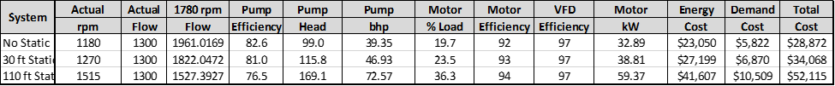

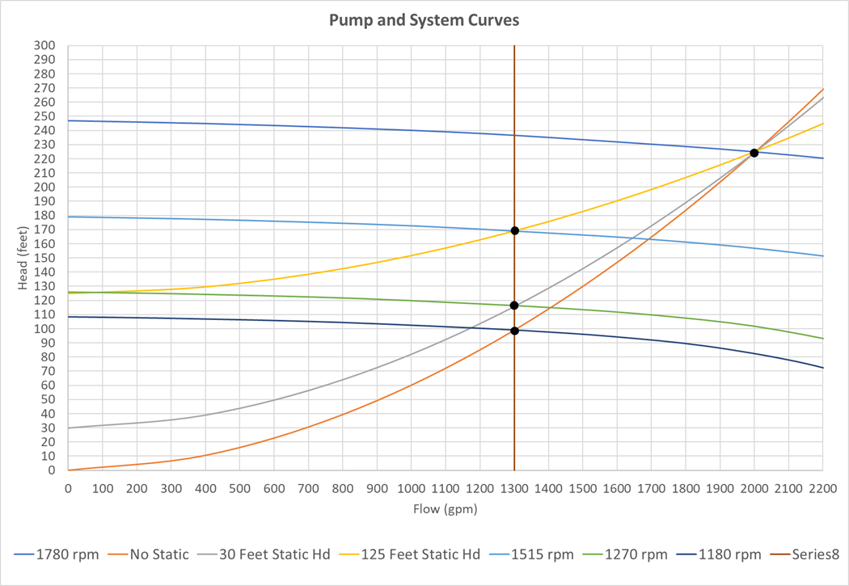

- Answer
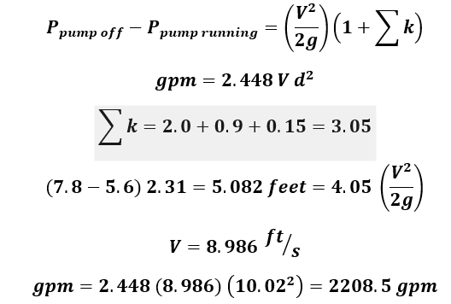

- Answer
Pump head reduction = (95 – 70) psig x 2.31 ft/psig / 0.93 = 62.1 feet
Energy savings = 4250 gpm x 62.1 feet x 0.93 x 0.746 /(3960 x 0.75 x 0.957) = 64.4 kW
Cost savings = 64.4 kW x 6 hr/day x 365 days/yr x $0.07/kWh = $9,873/year
The MEASUR solution is below.

