n

Name: _____________________________________________
Company: __________________________________________

- Create MEASUR files for several of the pumping systems you are investigating for energy savings. Complete as much of the analysis as possible. If you have questions, please email us.

Go the Extra Mile: If you have time work through some of the following!
Answers are after the questions.

- The pump below was selected for 2000 gpm at 225 feet of head. You are to investigate the operating points for this pump operating at 1500 rpm, 1000 rpm and 750 rpm for three different systems operating with a VFD for capacity control. The first system is all frictional with no static head. The second system has 30 feet of static head and the final system has 125 feet of static head. Determine the system curves in MEASUR. Then use Excel to do your analysis by plotting the three system curves and the pump curves at the different speeds to determine the different operating points. Determine the flow rate delivered, pump head and pump efficiency for each operating speed for each of the three systems. Does the amount of static head in the system impact the operating point of a pump controlled by a VFD?

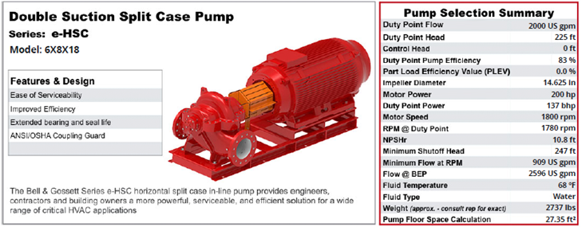

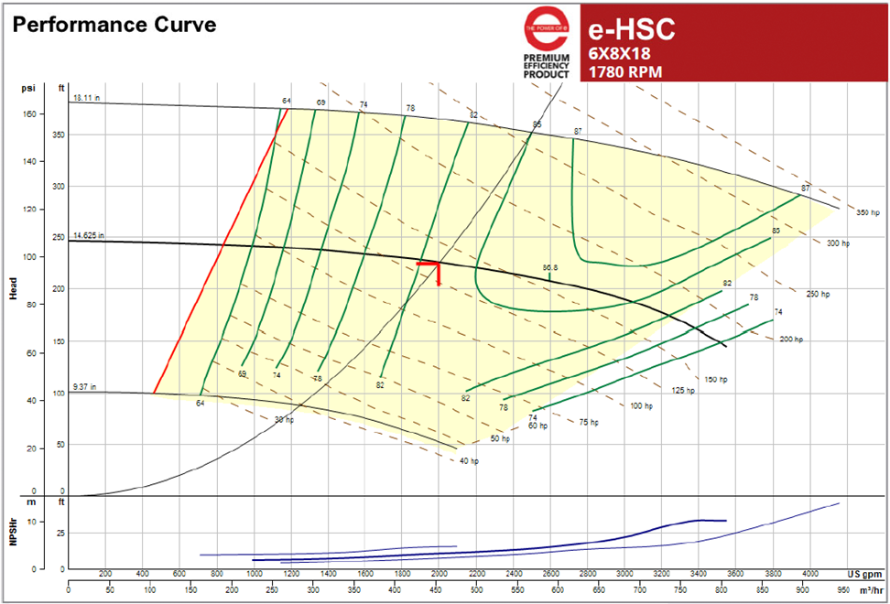

- A large cooling water system has a design operating point of 12,000 gpm at 140 feet of head. To deliver this flow 5 identical pumps must be operated in parallel. The system has 100 feet of static head, the open elevation of the cooling towers. In Excel input the system curve and pump curve. The plot the system curve plus equivalent pump curves for 1-pump, 2-pump, 3-pump, 4-pump and 5-pump operation. Give the system operating flows and heads for 1, 2, 3, 4, and 5 pumps. How much does the flow increase every time you turn on an additional pump?
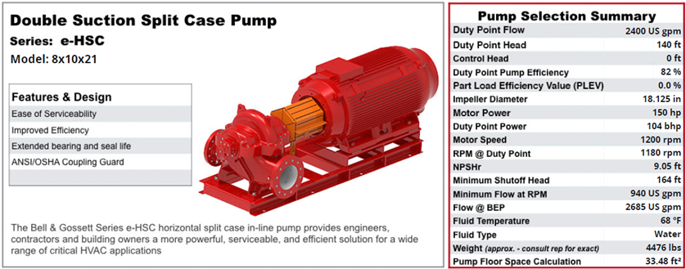

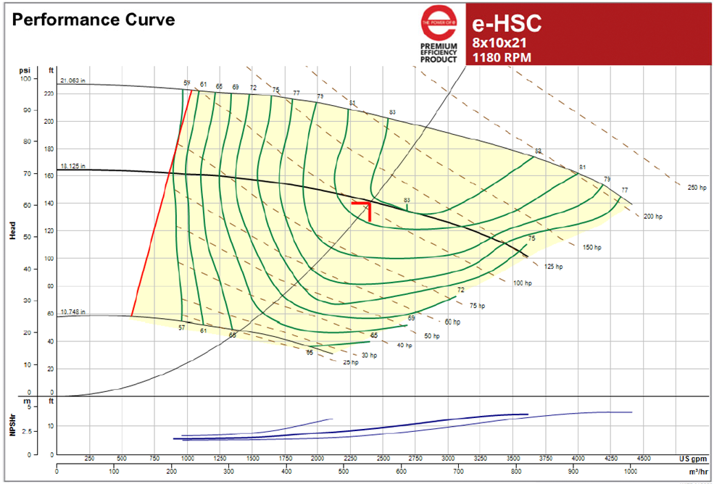

- A municipal water treatment plant needs to deliver 1.5 million gallons per day of fresh water into the system. An energy study has suggested the plant pump at a slower rate for a longer time to reduce the cost of pumping. The data below applies to this system. If electricity costs $0.08/kWh and demand costs $15.25/kW, calculate the annual operating cost for each flow rate.

Flow Rate (gpm) | Head (feet) | Time (hr/day)
1700 | 294.1 | 14.71
1900 | 302.3 | 13.16
2100 | 311.4 | 11.90
2300 | 321.5 | 10.87
2500 | 332.5 | 10.00

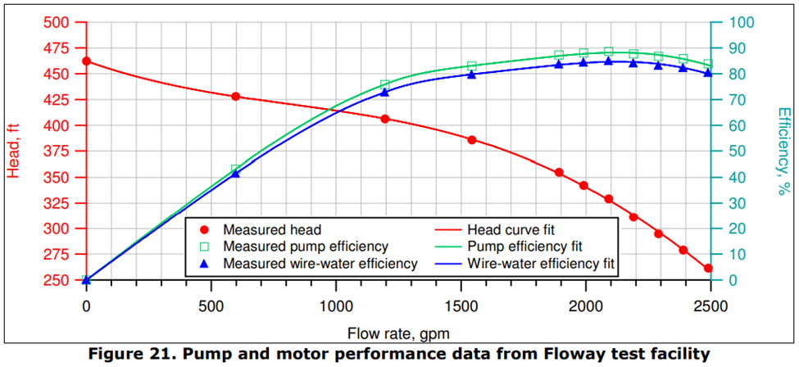

Answers

