n

Name: _____________________________________________
Company: __________________________________________
- Please prepare an inventory of one or two pump systems in your facility you wish to analyze and obtain the following data for each one of them.

- Hours/year of operation
- Cost of electricity, $/kWh
- Pump type
- Pump operating speed, RPM
- Drive type (Direct, Std V-belt, Notched V-belt, Synchronous belt, VFD)
- Fluid pumped
- Fluid Temperature, F
- Fluid specific gravity
- Fluid kinematic viscosity, cSt
- Number of pump stages
- Motor horsepower rating
- Motor rated RPM
- Motor efficiency class (Standard, Energy Efficient, Premium Efficiency)
- Motor rated voltage
- Motor full load amps
- Measured flow rate, GPM
- Measured pump head, Feet
- Measured motor power (kW with Power Meter or Volts & Current with clamp on meter)

- Why do you think this pumping system has energy reduction potential?
- List your questions about pumping systems in your facilities.

Go the Extra Mile: If you have time work through some of the following!
Answers are on the Next Page.

- A pump operates under the following conditions: flow is 500 gpm; suction pressure is 22.9 psig; discharge pressure is 127.4 psig; suction gauge elevation is 4 feet off the floor; discharge gauge elevation is 8 feet off of the floor; suction piping is 6 inch diameter; discharge piping is 5 inch diameter; the suction side loss coefficients total 1.75; the discharge side loss coefficients total 2.5; the fluid is corn oil with a specific gravity of 0.924. Calculate the pump head.

- Calculate the static head for the system below. Standard water is being pumped.

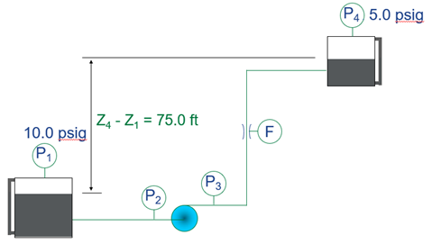

- Calculate the pump head for the figure below. The flow rate is 5000 gpm of standard water.

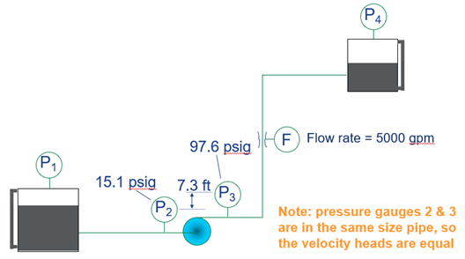

- Using the static head from Problem 2 and the pump head and flow from Problem 3, calculate the system curve this piping system. The equation should be of the form:

- A plant has a VFD installed on a fully loaded 100 hp pump. The operators continue to run the pump at 60 Hz and the automatic control system is not connected to the VFD. The VFD efficiency is estimated to be 97%. How much has the operating cost for the pump increased per year if the VFD is operated at 60 Hz continuously? The average net cost of electricity is $0.08/kWh and the electric motor efficiency is 95%.

- A chilled water closed loop piping system has a 200-ton chiller with the evaporator flow at 480 gpm of water at 42 F. This piping loop has a straight pipe length of 3500 feet, 2-gate valves (wide open), 10-std 90-degree elbows, 1-check valve, and 1-strainer (K = 2.0). The chiller evaporator has a 20-foot head loss and each of the 5 chilled water coils has a 12-foot head loss, all supplied by the chilled water circulating pump. Determine the following:
  - The size of the pipe is needed for the 480 gpm flow. (See slide 47)
  - The total head loss for the system assuming schedule 40 black steel pipe.
  - Go to the following link and select a chilled water pump for this system. ESP Systemwize (esp-systemwize.com)

Answers
- Suction pipe diameter = (Pi x (6/12)²)/4 = 0.19635 ft²
Discharge pipe diameter = (Pi x (5/12)²/4 = 0.13636 ft²
Suction flow velocity = (500 gal/min)/(7.4805 gal/ft³ x 60 s/min x 0.19635 ft²) = 5.6736 ft/s
Suction pipe velocity head = (5.6736 ft/s)²/(2 x 32.174 ft/s²) = 0.50024 ft
Discharge flow velocity = (500 gal/min)/(7.4805 gal/ft³ x 60 s/min x 0.13635 ft²) = 8.1700 ft/s
Discharge pipe velocity head = (8.1700 ft/s)²/(2 x 32.174 ft/s²) = 1.03731 ft
Pump elevation head = (8 ft – 4 ft) = 4 feet
Pump pressure head = (127.4 – 22.9) x 2.31 / 0.924 = 261.25 feet
Differential velocity head = 1.03731 – 0.50024 = 0.53707 feet
Suction line losses = 1.75 x 0.50024 ft = 0.8754 feet
Discharge line losses = 2.50 x 1.03731 ft = 2.5933 feet
Total Pump Head = 269.26 feet

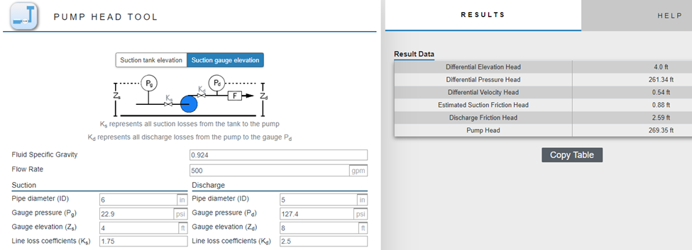

- Static Head = 75.0 + 2.31 x (5.0 – 10.0) = 63.45 feet

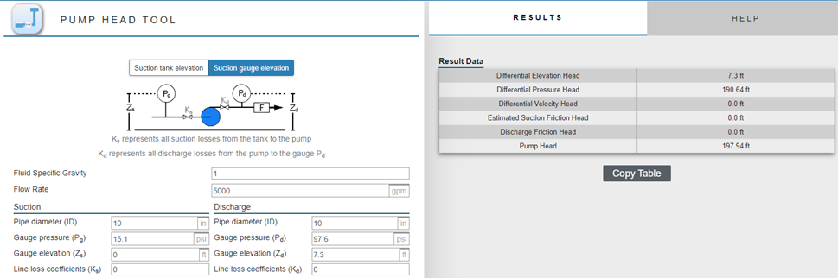
Pump Head = 197.94 feet
- Static Head = 63.45; k’ = (197.94 – 63.45)/5000^{1.9} = 0.0000126
System Curve Equation = 63.45 + 0.0000126 x Q^{1.9}
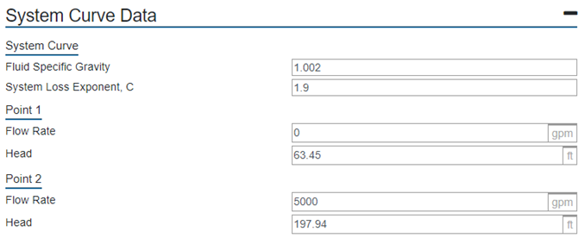
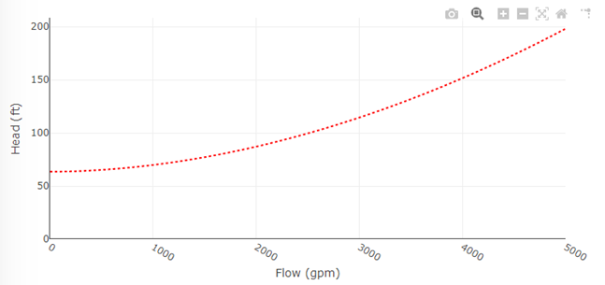
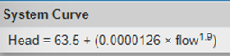

- Answer: kW with VFD = (100 hp x 0.746 kW/hp)/(0.95 x 0.97) = 80.95 kW
kW without VFD = (100 hp x 0.746 kW/hp)/0.95 = 78.53 kW
Extra Annual Cost for VFD Losses = (80.95 – 78.53) x 8760 hr/yr x $0.08/kWh = $1,696/yr

- 6” diameter pipe from slide 47
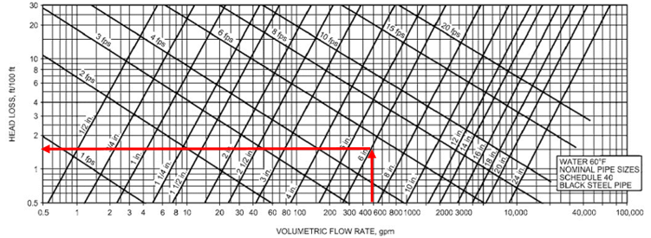

- Pump Head: Straight pipe 1.8 feet loss/100 feet of pipe = 1.8 x 35 = 63 feet
Calculate velocity in the 6-inch diameter pipe. Cross sectional area = (Pi x (0.5)²)/4 = 0.19635 ft². Flow velocity = (480 gal/min)/(7.48 gal/ft³ x 0.19635 ft² x 60 sec/min) = 5.447 ft/s
V²/2g = (5.447 ft/s)²/(2 x 32.174 ft/s²) = 0.461 ft
90-degree elbows = 10 els x 0.3 x 0.461 ft = 1.383 ft
Gate valves = 2 valves x 0.2 x 0.461 ft = 0.184 ft
Check valve = 1 valve x 2.0 x 0.461 ft = 0.922 ft
Strainer = 1 strainer x 2.0 x 0.461 ft = 0.922 ft
Cooling coils = 5 coils x 12 ft/coil = 60 ft
Total head loss = 146.41 feet
Select pump for 480 gpm @ 150 feet of head
Bell & Gossett e1510 3AD 6.625 inch diameter impeller, 23.2 bhp, 30 hp motor, 3550 rpm

