n

Name: _____________________________________________
Company: __________________________________________
- Draw a diagram of one of your pumping systems you think may have energy saving potential.
  - Include the pump make, model and horsepower if possible.
  - Try to find the pump curve.
  - Include the valve types, sizes, and typical positions.
  - Estimate the pipe lengths and sizes.
  - What is the typical system flow and the pump suction and discharge pressures?
Example Diagram
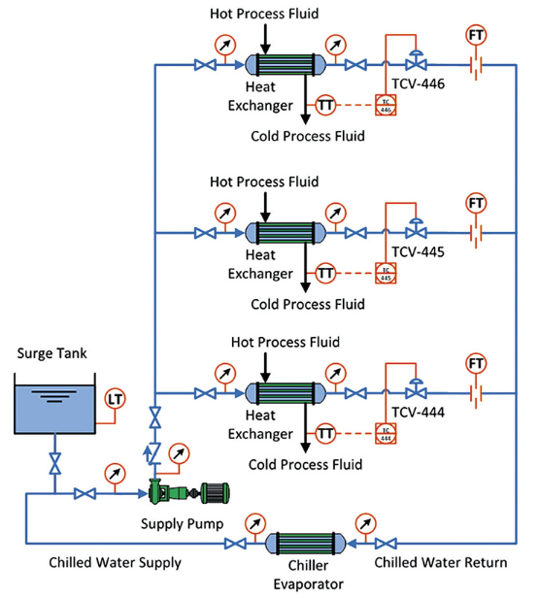

Go the Extra Mile: If you have time work through some of the following!
Answers are on the Next Page.

- If a plant’s net cost of electricity is $0.12/kWh and their pumps typically operate 60% of the time, what is the minimum motor size on a pump that will cost $20,000/year to operate? Hint: see slide 20.

- The flow control valve on a boiler feedwater pump typically operates 50% open with a flow rate of 200 gpm of water going to the boiler at 250 F. Plant engineers measure a pressure drop of 115 psi across the valve. If the pump efficiency is 72% and the motor efficiency is 92%, how many kW in motor input energy is being dropped across the valve?

- If the boiler feedwater pump in #3 above operates all the time and the cost of electrical energy is $0.065/kWh and the demand charge is $14.75/kW-mo, how much does the energy loss across the throttled valve cost the plant per year?

Answers

- Answer: 40 hp (from slide 20)
- Answer: Density of water at 250 F is 58.82 lb_{m}/ft³; the density of water at 60 F is 62.36 lb_{m}/ft³; so, the specific gravity is 58.82/62.36 = 0.9432.
The head loss across the valve is: HL = (115 psi x 2.31)/0.9432 = 281.65 feet
The kW of pump motor power lost across the valve is:
kW = (200 gpm x 281.65 feet x 0.9432 x 0.746 kW/hp)/(3960 x 0.72 x 0.92) = 15.11 kW

- Answer: Energy Cost = (15.11 kW x 8760 hy/yr x $0.065/kWh) = $8,604/yr
Demand Cost = (15.11 kW x $14.75/kW x 12 mo/yr) = $2,674/yr
Total Annual Cost = $11,278/yr

