Name: _____________________________________________
Company: __________________________________________

- Steam is directly injected in a vessel to heat water from 65°F to 135°F and the required flow for the process need is 100 gpm.
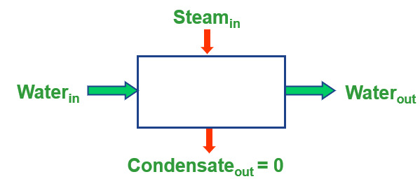
  - Calculate the steam flow rate required ___________________
  - Compare the results with the indirect heat exchange application and comment on which method would you recommend for use in your plant.
___________________________________________________________________________
___________________________________________________________________________
- Use the Steam System Scoping Tool (SSST) on your industrial plant steam system and prepare a high-level list of potential areas for investigation in a steam system energy assessment over the next 6 weeks.
_________________________________________________________________________________
_________________________________________________________________________________
_________________________________________________________________________________

- Prepare a line diagram for your steam system showing the boilers, headers, major end-users, and condensate return system. Indicate pressures, steam flows and anything important for your system. (It doesn't have to be pretty.)

