

SESSION 6

**Workbook**

|  |
| --- |
| **Statepoint Analysis**​ |
| **Tools of the Trade**​ |
| **Closing Remarks**​ |

|  |
| --- |
| **Welcome**​ |
| **Opportunity Register Report Outs**​ |
| **Optimizing RAS Rate**​ |

|  |
| --- |
|  |
|  |
|  |
|  |
|  |
|  |
|  |
|  |
|  |
|  |
|  |
|  |
|  |
|  |
|  |
|  |
|  |
|  |

**Notes On ras optimization**

|  |
| --- |
|  |
|  |
|  |
|  |
|  |
|  |
|  |
|  |
|  |
| |  | | --- | |  | |  | |  | |  | |  | |  | |  | |  | |  | |  |   **Notes On Statepoint analysis** |

**Sample Exercise**

The anaerobic digester mix pump continuously pumps 1,175 gal/min against a total dynamic head of 48 ft. From the manufacturer’s literature, the pump is 74% efficient and the motor is 92% efficient. The average cost of electricity is $0.1012/kWh. The CPO conducted a study that found no deterioration in performance—measured in terms of VSR, gas production and gas composition—when turning the mix pump off for 20 minutes every 30 minutes (i.e., 10 min on, 20 min off). Calculate the annual electrical cost savings realized with this new operation, ignoring demand charges.

**Given**:

Pumping rate, Q = 1,175 gal/min

TDH = 48 ft

Motor efficiency = 92% = 0.92

Pump efficiency = 74% = 0.74

Old operation = 24 h/d

New operation = 10 min/30 min

Cost of electricity = $0.1012/kWh



**Optimizing Return Rate Exercise**

This equation,

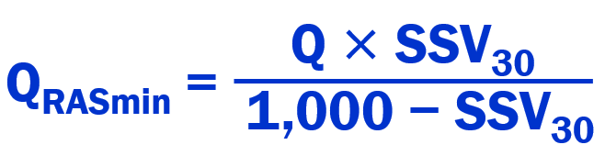

Can be rearranged to:

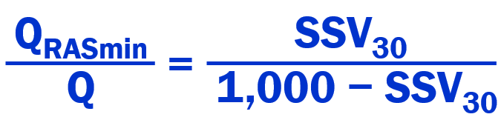

The factor below and on the left hand side of the equals sign, as calculated (times 100 to get %) is the minimum RAS flow percentage:

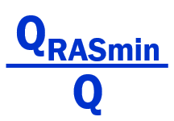

.

Calculate the minimum RAS flow percentage for SSV30s of 125, 150, 175, 200, 250, 300, 400, 500, and 600 mL/L. Comment on the impact that sludge compaction has on the potential for lowering RAS pumping costs.

|  |  |
| --- | --- |
| **SSV30, mL/L** | **RAS flow, % (QRASmin/Q)** |
| **125** |  |
| **150** |  |
| **175** |  |
| **200** |  |
| **250** |  |
| **300** |  |
| **400** |  |
| **500** |  |
| **600** |  |

**SRT Exercise**

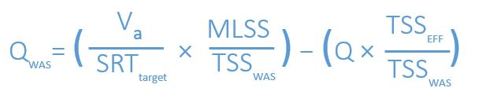From experience the process control engineer knows that an SRT target (aerobic) of 7 days will meet the effluent NH3 requirements during the winter. However, because the supernatant in the modified settleometer test has been turbid, she wants to increase the SRT target to 7.5 days.

|  |
| --- |
| From the following recent data, calculate the new WAS flow rate (gal/hr):  Q = 2.6 Mgal/d  MLSS = 2,550 mg/L  Va = 0.65 Mgal (aerobic)  TSSEFF = 16 mg/L  TSSWAS = 7,700 mg/L |