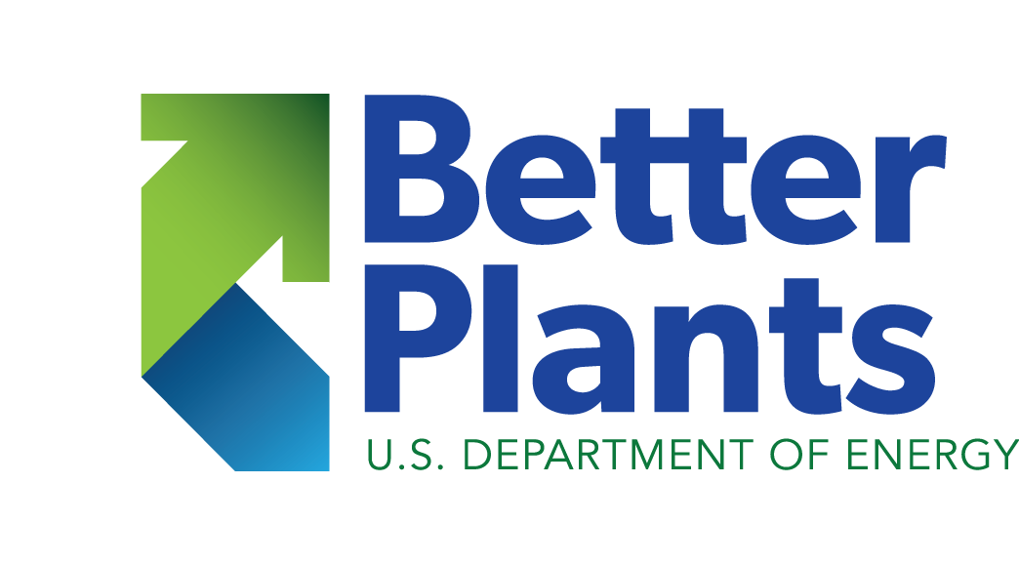

SESSION 5

Workbook

Topics for the week
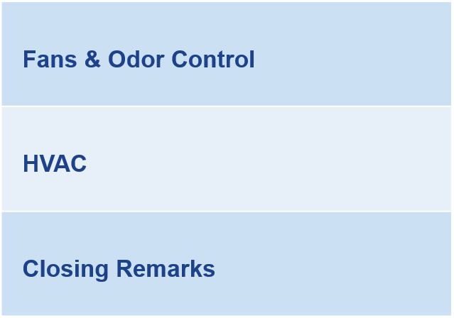
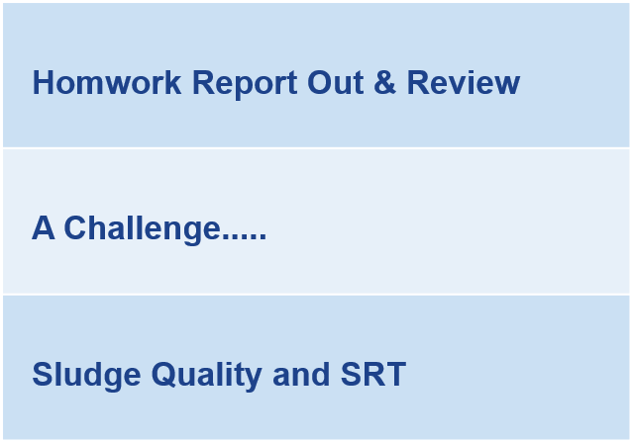

Sludge Quality Not Effluent Quality
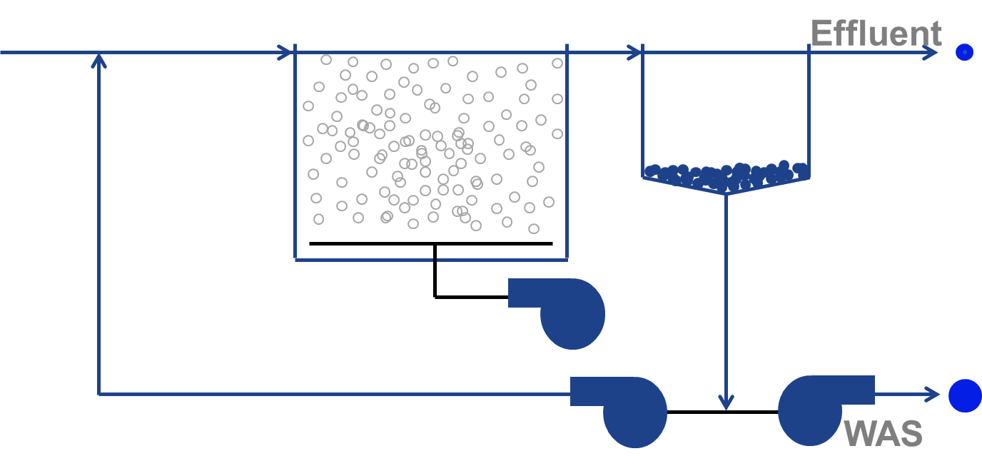
Intentional wasting
Unintentional wasting

Notes

exercise – WAS Flow
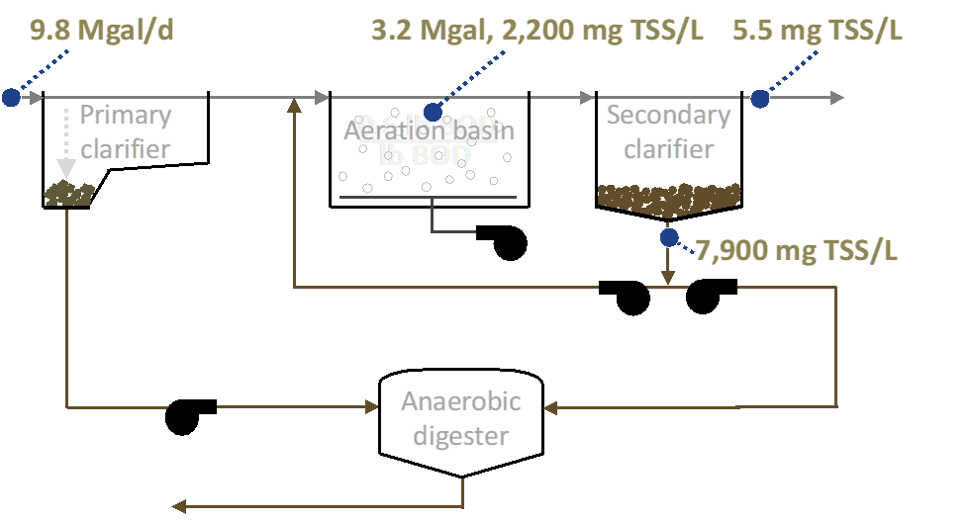The operational strategy is to keep as little sludge blankets in the secondary clarifiers as possible. Over the last 24 hours, the online TSS meter measuring the mixed liquor suspended solids has averaged 2,200 mg/L. The secondary clarifier effluent TSS average a consistent 5.5 mg/L. The suction lines to the RAS and WAS pumps come off the same header. The return ratio is maintained at a constant 45% giving a TSS concentration in the RAS of 7,900 mg/L. The plant flow averages 9.8 Mgal/d and aeration basin volume currently online totals 3.2 Mgal. Using the information in the graphic above:
- Calculate the WAS flow necessary to maintain the following SRT_{TARGETS}
  - 3 days (Plant is not nitrifying)
  - 6.5 days
  - 9 days (Full Nitrification)

- For those of you with Activated Sludge, use your most recent applicable plant data and:
  - Perform the same calculations.
  - Report what there SSV30..for those that have an AS

