SESSION 4

Workbook & Homework

Agenda
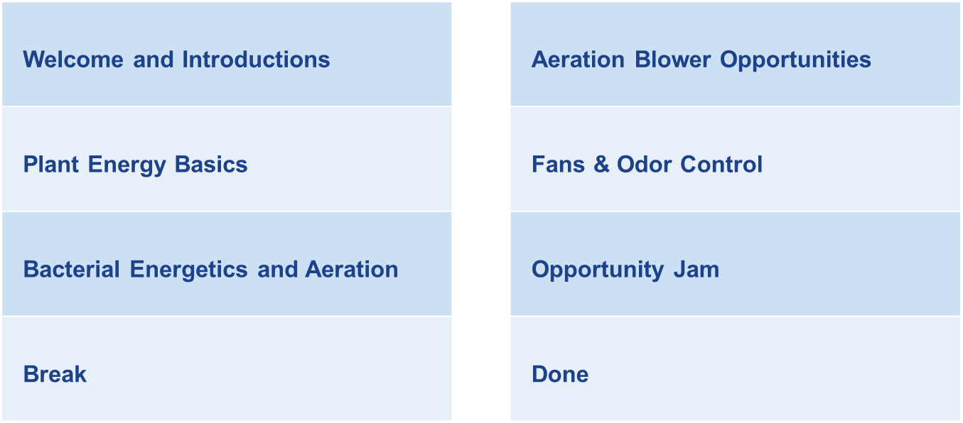

notes: bACTERIA ENERGETICS AND AERATION

notes: AERATION, Fans, and Odor Control

Exercise: OUR – Finding endogenous RESPIRATION
Materials needed: Laptop, Internet access
Part 1: An Example problem. A 3-pass aeration basin is shown below. On the following page are the results of 7 OUR tests performed on the basin.
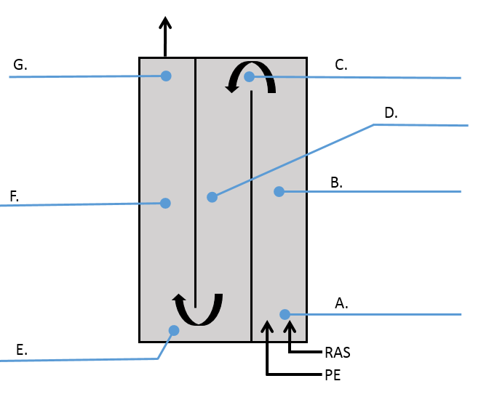

- Using MEASUR, determine the OUR for each of the 7 tests.

- Where does endogenous respiration begin?

- Where does this basin need the most air? The least?

- What are some possible approaches to optimizing the air in this basin?

Location: A. Beginning Pass 1 (after PE and RAS)
Time (seconds) | DO (mg/L)
0 | 7.45
10 | 7.02
20 | 6.59
30 | 6.18
40 | 5.72
50 | 5.29
60 | 4.88
OUR:
Location: B. Mid-tank Pass 1
Time (seconds) | DO (mg/L)
0 | 7.44
10 | 7.12
20 | 6.81
30 | 6.48
40 | 6.16
50 | 5.84
60 | 5.52
OUR:
Location: C. End Pass 1 beginning Pass 2
Time (seconds) | DO (mg/L)
0 | 7.48
10 | 7.21
20 | 6.93
30 | 6.68
40 | 6.40
50 | 6.14
60 | 5.89
OUR:

Location: D. Mid-tank Pass 2
Time (seconds) | DO (mg/L)
0 | 7.47
10 | 7.31
20 | 7.15
30 | 7.00
40 | 6.85
50 | 6.69
60 | 6.52
OUR:
Location: E. End Pass 2 beginning Pass 3
Time (seconds) | DO (mg/L)
0 | 7.17
10 | 7.02
20 | 6.86
30 | 6.70
40 | 6.57
50 | 6.43
60 | 6.27
OUR:
Location: F. Mid-tank Pass 3
Time (seconds) | DO (mg/L)
0 | 7.37
10 | 7.32
20 | 7.28
30 | 7.24
40 | 7.20
50 | 7.15
60 | 7.10
OUR:
Location: G. End Pass 3, aeration basin effluent
Time (seconds) | DO (mg/L)
0 | 7.42
10 | 7.39
20 | 7.33
30 | 7.30
40 | 7.25
50 | 7.22
60 | 7.18
OUR:

EXERCISE – AERATION PRESSURE

Purpose: To develop knowledge, comfort and proficiency with the relationship between energy and aeration air discharge pressure.

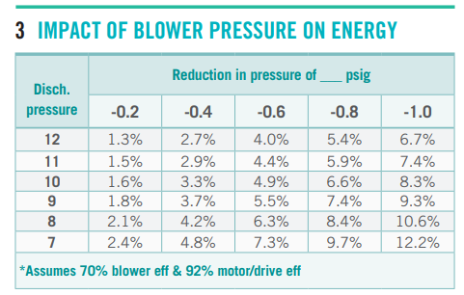
Activity Questions
- How much energy is saved if this 50 hp blower’s discharge pressure is reduced from 7 psig to 5.5 psig? | kWh/year
- What if it’s a 150 hp blower, and the pressure is lowered from 10 psig to 9.5 psig. What percentage of energy is saved? | %
- If a 75 hp blower is turned down from 11 psig to 9 psig, how much money is saved (if energy costs 6¢ per kWh)? | $ /year
- If a 40 hp blower is turned down from 8 psig to 7 psig, how much energy is saved, and what percentage does that represent? | kWh/year | %

EXERCISE – DO RESIDUAL
Purpose: To develop knowledge, comfort and proficiency with the relationship between energy and residual dissolved oxygen (DO).
Materials needed: Laptop
Oxygen is required by the organisms that carry out secondary treatment in the aeration basin. Installed DO meters read how much “residual” or leftover oxygen is present. While many plants control blower operation automatically to maintain 2 mg/L DO or lower, we also see that many aeration basins carry excess DO “just in case” a large load comes in unexpectedly. This extra DO has an energy cost. The cheat sheet table shows how much energy savings (as a percentage) is available if residual DO is reduced to 2 mg/L, at various mixed liquor temperatures.
The cheat sheet allows you to explore different scenarios and determine the approximate actual savings associated with these scenarios.
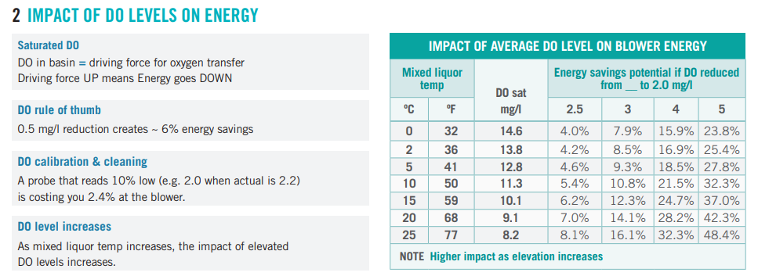
Instructions: Use the table and cheat sheet above to answer the questions below.

Exercise – DO ResiduaL continued

Questions
- What percentage of energy could be saved if an aeration basin holding 25ºC mixed liquor lowered its DO residual from 3 mg/L to 2 mg/L? | __________%
- If a plant is running 200 hp of blowers, and it has 59 ºF mixed liquor, how many kWh/y of energy might it save by lowering its DO from 3 mg/L to 2 mg/L? | __________kWh/year
- In b) how much cost is saved (at $0.06/kWh)? | $_________/year
- How much total money can be saved if a plant running 100 hp of blowers in 20 ºC mixed liquor reduces their DO residual from 5 mg/L to 2 mg/L? | __________kWh/year
- Your plant runs (on average) what total horsepower of blower?  What is the approximate temperature of your plant’s mixed liquor? What is the DO residual setpoint at your plant? | __________hp  __________ ºF  ___________mg/L
- How much total money is saved if your plant reduces DO residual to 1 mg/L? | $_________/year

