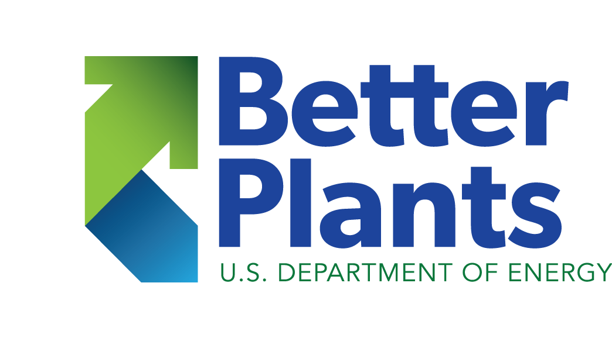

SESSION 3

Workbook

Agenda

Welcome/Opening​
Old Homework Review​
​Headworks & Disinfection​
Break​
​Primary Solids & Clarification​
New Homework Review​
Energy & PD Blowers​
Wrap-up​

Homework review
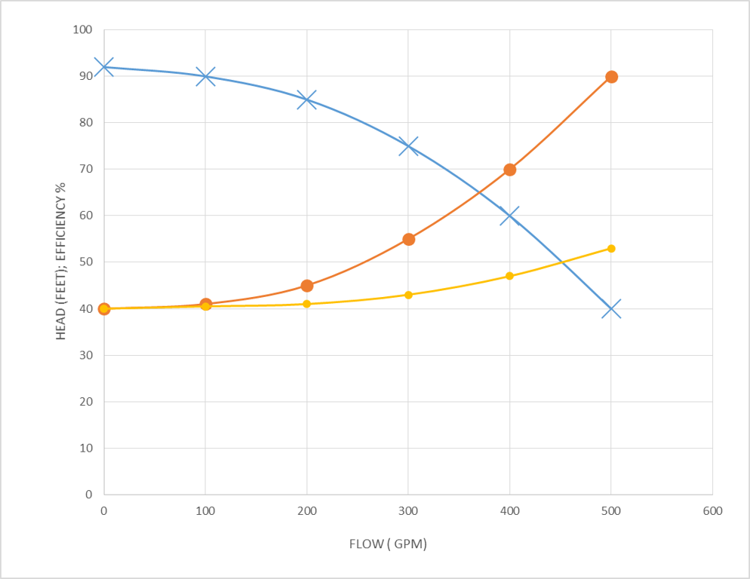
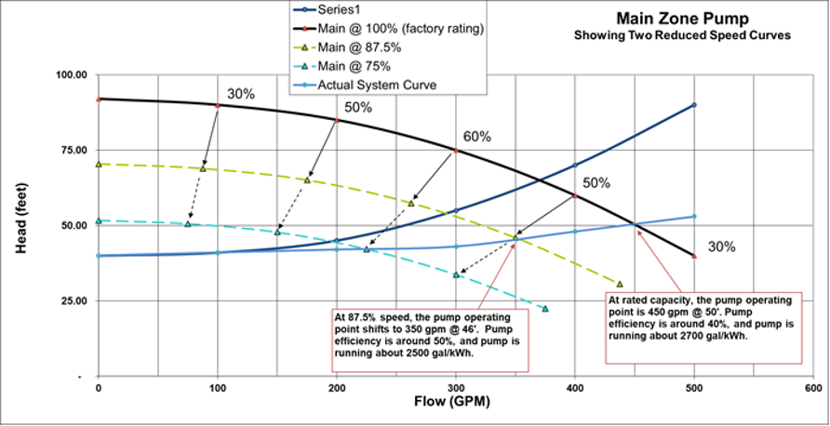

Opportunity Brainstorming and Prioritizing
All energy projects can be placed in one of the four quadrants listed below.
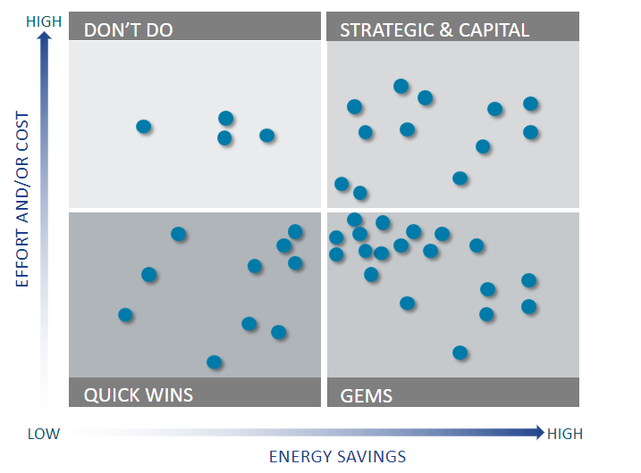

Quick Wins – Quick and easy opportunities that should be implemented in the short term (~1 to 4 months).
Gems – Medium to High energy saving opportunities that the team should prioritize over all others, and complete as soon as possible.
Strategic – Opportunities that require additional effort and/or investment and should be considered for future implementation.
Don’t Do – Not worth pursuing at this time given the high effort required and low energy savings.

Notes & Opportunities on Headworks & Disinfection

Notes & Opportunities on Primary Clarification:

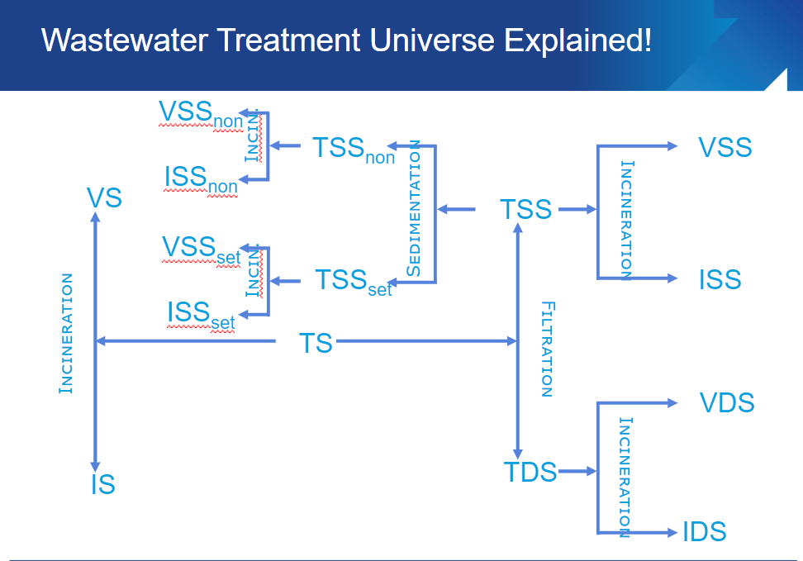

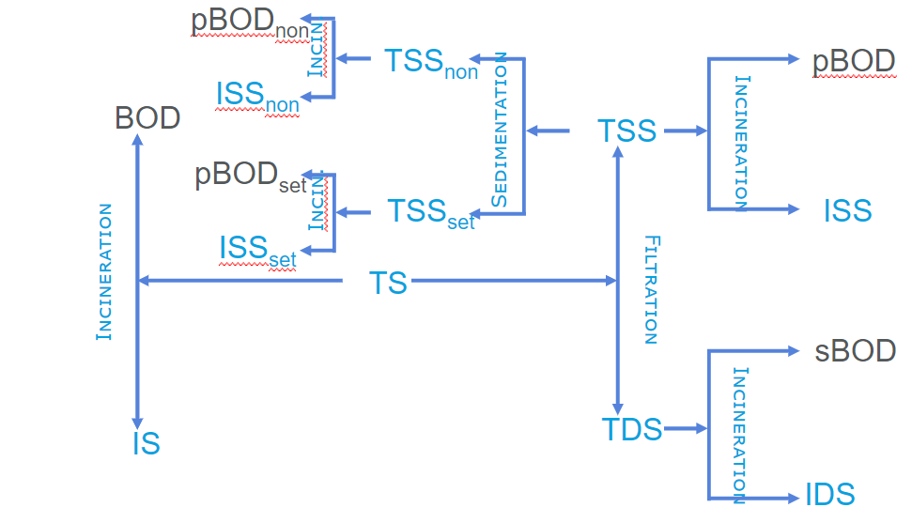

PD Blower Energy Example

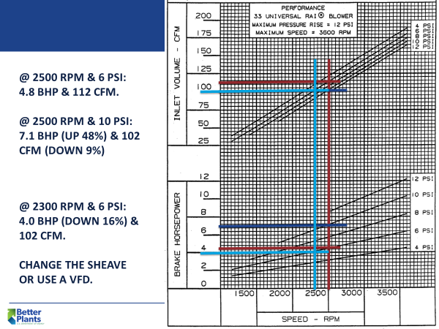

HOMEWORK
- For those of you with Primary Clarifiers perform the following 2 tests:

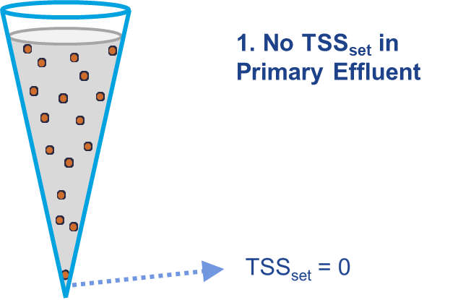

RESULT: ______________________________________

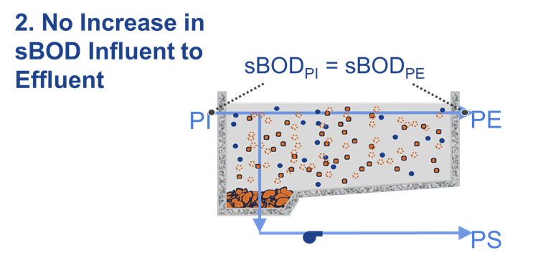
sBOD_{PI}: _______________________________

sBOD_{PE}: _______________________________

HOMEWORK

Think of three motors that are currently operating in your plant that you think you can reduce the runtime on, either through a timer or other automatic control.
List the motor equipment involved & fill in the table in your Workbook:
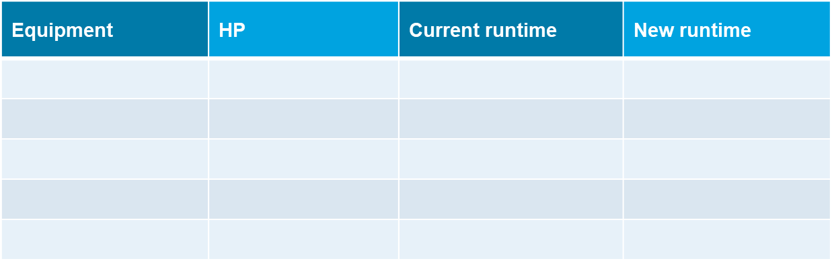
Now, estimate the energy savings that will occur should you implement this opportunity

