1

INTRODUCTION TO WASTEWATER ENERGY OPTIMIZATION

SESSIONS 2 Workbook

Agenda
SESSIONS 1 & 2
Opportunity Register
Plant Process Conservation
Wastewater Efficiency – Cheat Sheet
Plant Energy Basics and KPIs
Follow the BOD
Pumping Systems and Energy
W3 Systems & The DIY W3 Walkthrough
Energy Hot Spots

HOMEWORK– Follow the BOD
Purpose
To develop an understanding of the life of BOA as it moves through the plant as well the impact of the primary clarifier has on potential decarbonization.

Using the example from the webinar and shown below, complete the table on the following page:

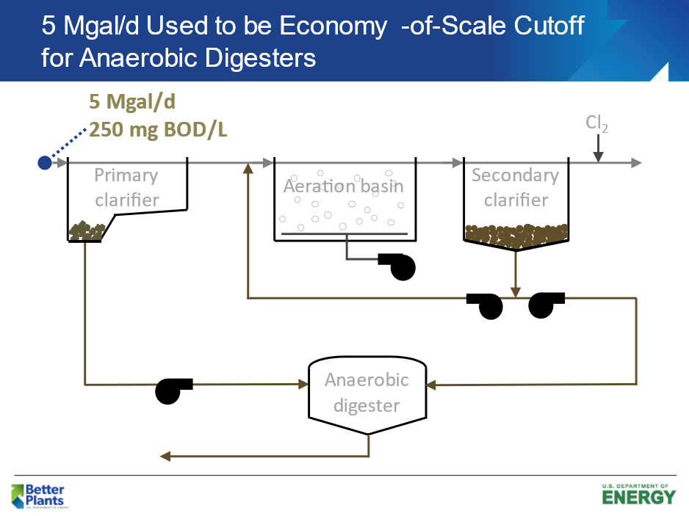

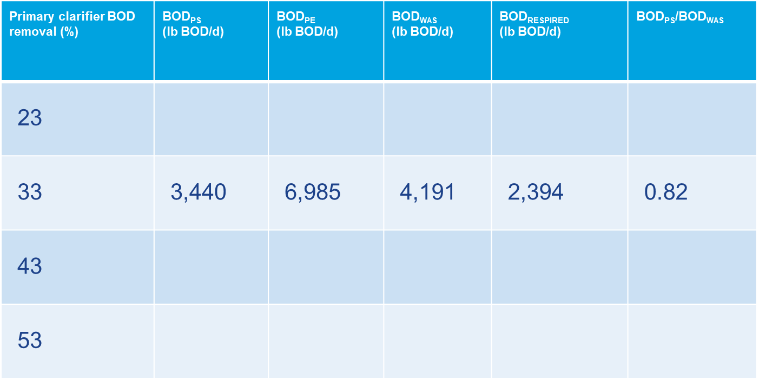

HOMEWORK– PUMP CURVE
Purpose
To develop knowledge, comfort, and proficiency with reading a pump curve and understanding the energy-use implications.
On the following page is a Pump Curve Cut-sheet for a specific design point. This pump was selected after determining the required flow rate and estimated head as indicated by the “red arrowhead”..

Instructions: Using information from the pump curve on the following page, answer the questions below in the activity sheet on the

- What is the design flow rate, estimated head, and efficiency?
- If we throttle this pump to decrease the flow to 300 gpm, what will be the resulting head pressure? | t
- If we throttle this pump to decrease the flow to 300 gpm, what will be the resulting pump efficiency?

.

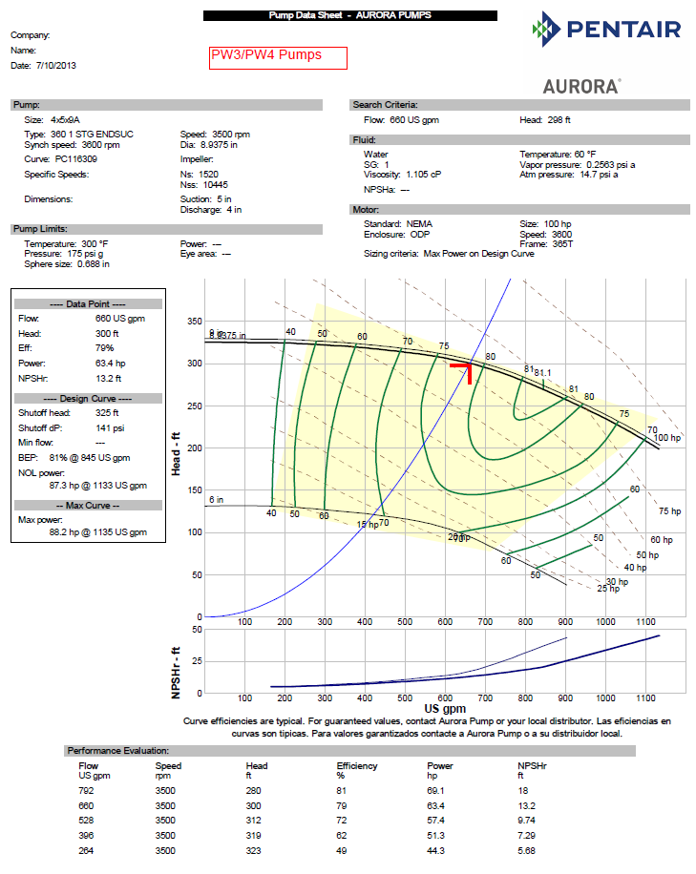

Activity sHEET – EXERCISE – DESIGN ENGINEER FOR A DAY!
Using the information below fill in the chart and table on the following page:

Design Flow Rate: 350 GPM
Discharge elevation 475 ft.
Wet-well water level: 435 ft

Frictional Headloss calculations

150 GPM = 3 foot
250 GPM = 9 feet
350 GPM = 20 feet
450 GPM = 40 feet
500 GPM = 50 feet

PUMPING ENERGY MATH

Q = GPM; H = FEET; S.G. = 1 FOR WATER; $η$= PUMP EFFICIENCY

BHP = S.G. * Q * H
$$3960η$$

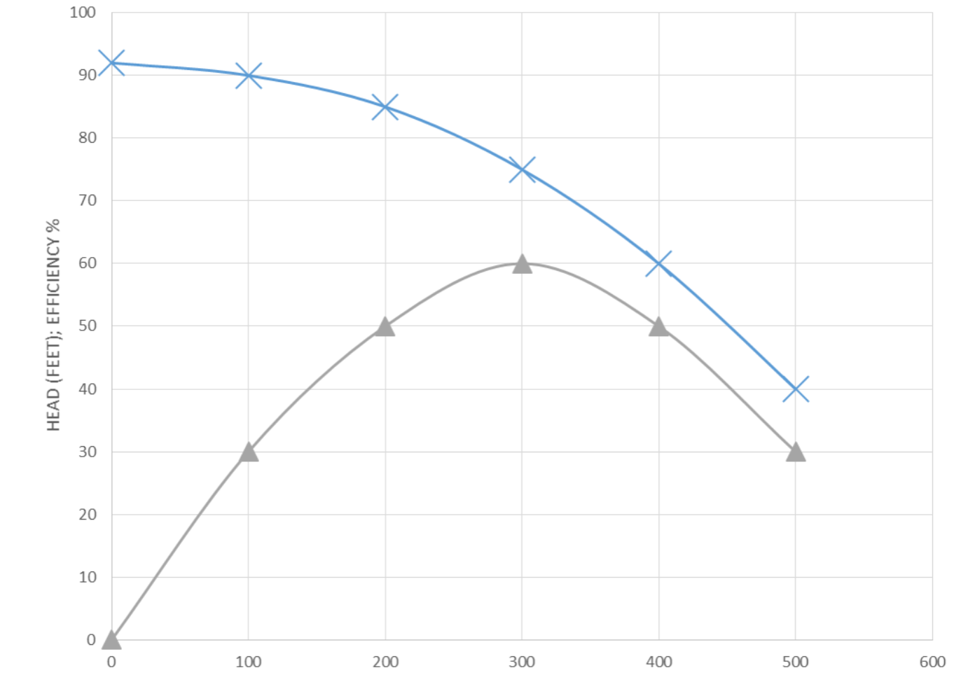

FIRM: ______________________________________
SYSTEM CURVE BY: _____ DATE: _____
PUMP SELECTION BY: _____ DATE: _____

Condition | Flow (gpm) | Operating kW | kWh/MG | GPM / kW
Design
Installed
Throttled
VFD

Session 2 Opportunity register jam session

