1

INTRODUCTION TO WASTEWATER ENERGY OPTIMIZATION

SESSION 1 Workbook

- What is one thing you are doing at your plant right now that you consider is saving energy over the alternatives available?

- What is one thing you are doing at your plant right now that you consider is a wasting energy?

Energy Basics Exercise
Purpose
To develop knowledge, comfort and proficiency with:
- energy units and calculations
- the relationship between energy and water
In the winter of 2019, Sickofthetide, Alabama’s WRRF received the electric bill shown below. Sickofthetide’s facility is an activated sludge plant that processes wintertime flows
averaging 6.5 MGD.

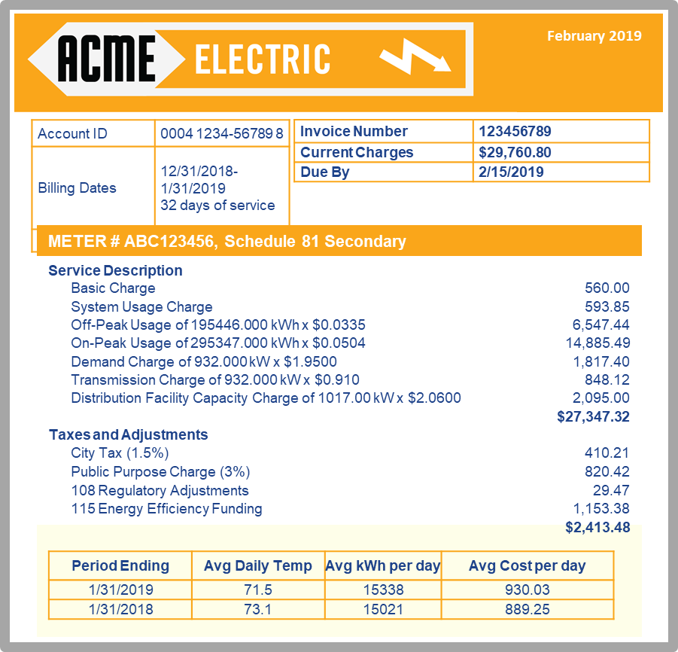
Instructions:
Using information from the energy bill above, answer the questions in the activity sheet on the next page.
- From the info above, what is the average whole-plant benchmark
in kilowatt-hours per million gallons treated?
- How many kWh do the two blowers consume on average every day?
- The plant runs two of its four 150 hp blowers all the time in the winter.
How many kW of power do the two blowers draw?
- How much cheaper is their off-peak rate than their on-peak rate?
- How many kilowatt-hours of electricity did this facility use during this billing cycle?
(January 2019)

- DIY W3 WALK-THROUGH NOTES

