Preparations for the ORNL 50001 Ready Training
The training will much more valuable and rewarding if you get a copy of the ISO 50001: 2018 standard and create a 50001 Ready online account for your site. Details follow:

- If you would like to have a copy of the ISO 50001: 2018 Energy Management Systems standard for a reference, you can go online here to purchase one:
https://webstore.ansi.org/Standards/ISO/ISO500012018
- Set up an account for the 50001 Ready NAV 3.0 (Google Chrome browser is BEST)
- You can work on this ahead of time. We will go over this in the first session, also.
- Please set up only ONE project per site. This should be done by ONE person.
  - Go to link: https://navigator.lbl.gov/partnerReferral?referralCode=ORNL2021
  - Also, you can copy and paste this link into your Google Chrome browser
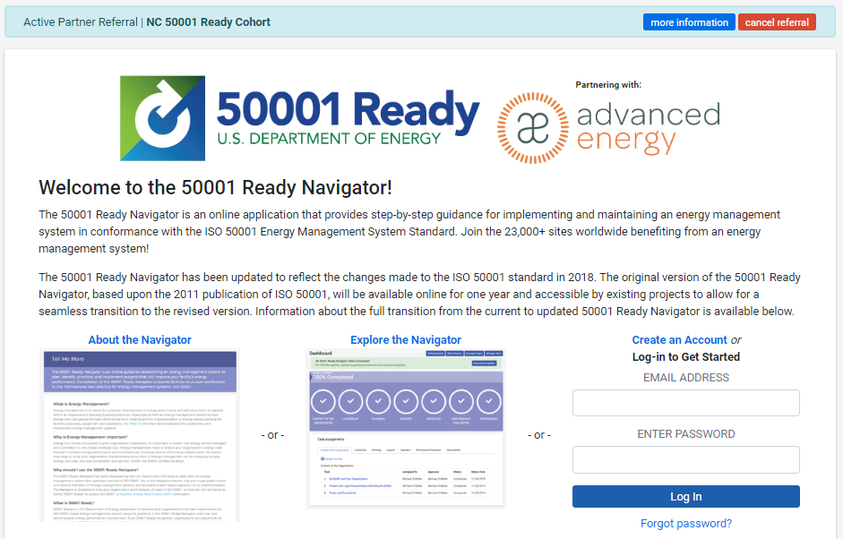
  - This will take you to the 50001 Ready landing page:

  - Click on “Create an Account”
  - This will take you to the next screen where you can enter your email address and create a password for your account
  - Others at your site can be added later

  - There are specific criteria for your password
  - Enter your email address and create your password on this screen:
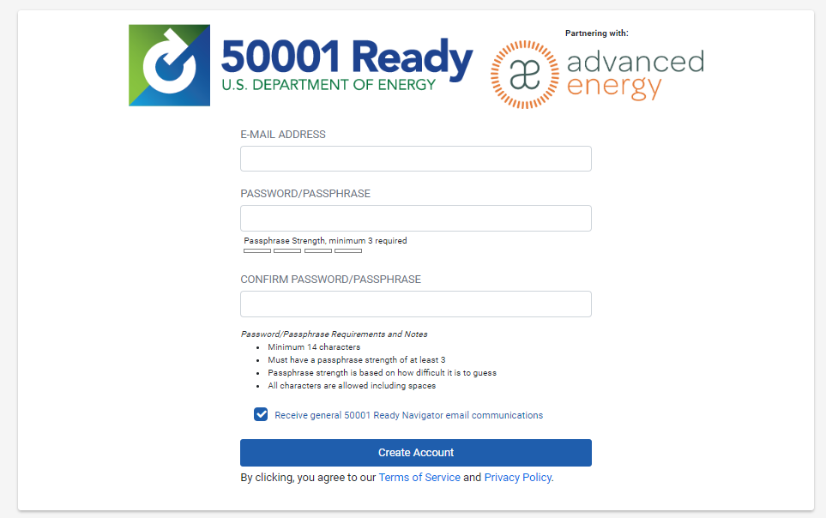

  - Click on the blue bar “Create Account”
  - Review the information and user agreement
    - Click on the “I Accept…” blue bar
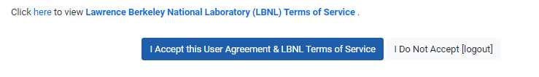

  - Next go through several screens to fill out the requested information about your site including:
    - Your name
    - Company and job title
    - Country, address, and website

  - Next you will need to select between two choices:
    - Your Own Site (default) – One site working on their own, OR
    - Multi-Site – This is for a company with a central office and multiple sub-sites under this central office
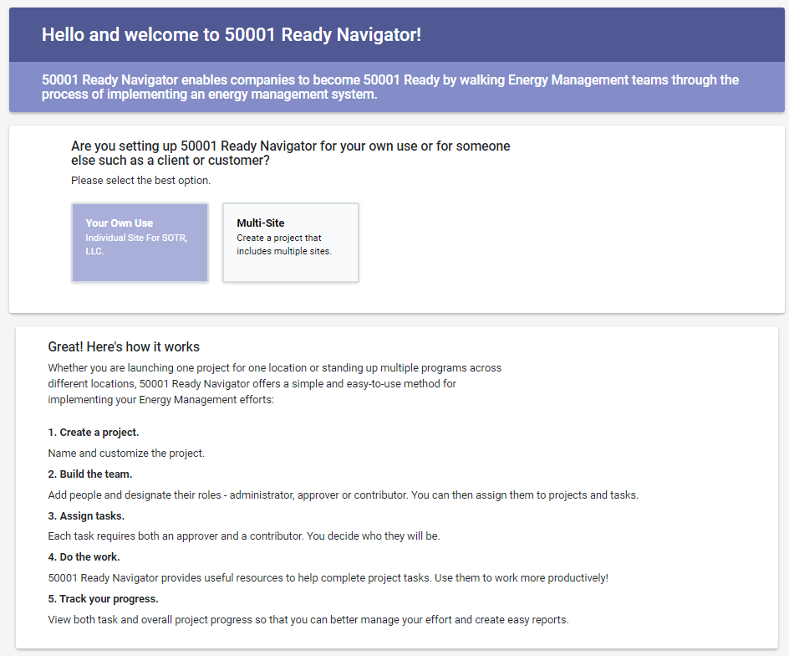
    - Click on one of these two boxes based on your situation. Pick “Your Own Use” (default for single site) or you can click on the multi-site button:

    - Read through the “Great! Here’s how it works” section

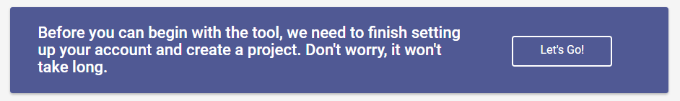
    - If you stayed on the default of “Your Own Use”, then next click on the “Let’s Go!” button

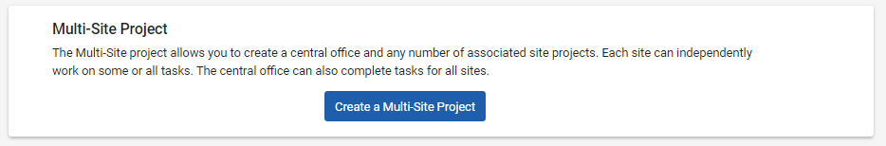
    - If you selected the Multi-Site button you will see the following and should then click on the “Create a Multi-Site Project” button

    - For either choice, “Your Own Use” or “Multi-Site”, you will next complete more information for your project account
    - The instructions below show information for “Your Own Use” (single site)
    - If you selected Multi-Site, please contact me if you need assistance

  - Create your project (single site)
    - Through several screens, fill in the requested information about your project
    - You can select if you have experience with other ISO standards or the Energy Star program
    - You can select your project sector
    - You can associate your project with several energy management programs such as Better Plants, etc.
    - You will need to associate your project with the ORNL 50001 Ready Cohort
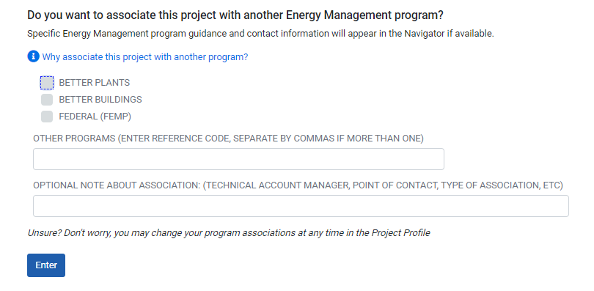
      - In the “OTHER PROGRAMS box, enter this reference code: ORNL2022

    - A very key item here is to build your team (third page of project set up)
      - Here you will add the names and emails of everyone at your company that you want to be on the energy team for this project
      - Your name and email will appear on the first line
- Fill out name and email for additional team members
- Please add Michael Stowe to all project teams as administrator
- For each added member select user or administrator
- Click “+Add another team member” to add more members
- People you add here will get an email to set up their own accounts on your projects. You can add a note to the emails here.
- Once all team members are added, click the “Enter” button

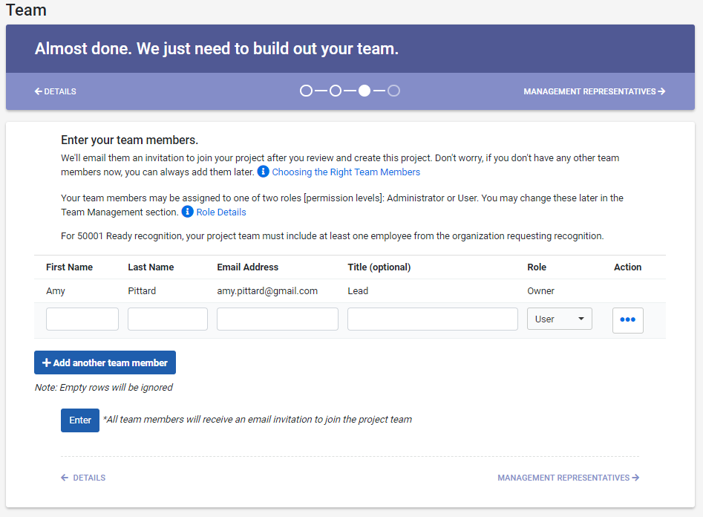
Your Name
Your Email

  - Each added team member will get an email and can then set up their own email and password access. We will go over this early in the training.
  - When you have completed this, you should be able to see your site project dashboard, see next picture below:

- It is very important to have your site project set up in the 50001 Ready navigator before the Webinar Session TWO, on June 3, 2020. We will be using the 50001 Navigator and its playbooks, in addition to a PowerPoint slide deck during the webinars.
  - We will check on this with everyone during the first webinar
  - If you have any issues with this, please contact us (see below)

- Next, select your top management and energy management representative. You will select these from a pull-down menu of the people you just added to your team.
      - Click the “Enter” button

- Next, a summary page will come up where you can review and edit the information you have just entered
      - When all set, click “Submit”
- Then click “Show Me My Project” and you will see the screen below
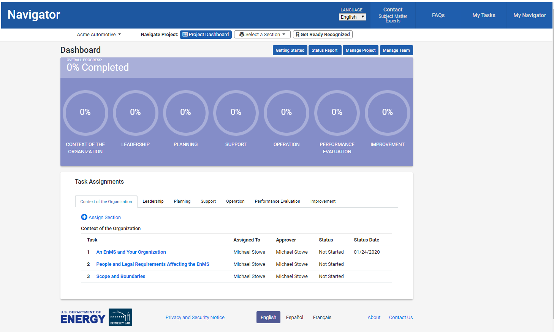

- Once you have set up your project in 50001 Ready, take some time to play around and move around in the site to check out the following:
  - My Navigator pull down menu
    - This has account management items and lots of good background info
    - The “Getting Started” section is good to review
    - This is also where you logout
  - My Tasks button
    - List all the 25 task, roles, and status
  - FAQs Button
    - List several sections of frequently asked questions all about the navigator
    - It would be good to review this
  - My Projects Overview (under the My Navigator pull down menu)
    - A quick view of task status
    - Click on the 0% to see the project dashboard
  - The Dashboard
    - Shows all seven sections with a percent completion circle
    - Click on any section tab to see the tasks for that section
    - Click on any task to see the details of that task

Things to BRING with you to the Webinar Sessions:
Please try to bring, or have available on your laptop, as much of the information below, as possible. We will be using this information for various activities throughout the eight sessions:
- Your laptop computer with your 50001 Ready account set up
- You will need to have a good internet connection during the training sessions
- Information about your site, as applicable:
  - Google Maps aerial view of your site
  - Total square footage
  - Total air-conditioned square footage
  - Raw materials IN
  - Final products OUT
  - General process flow description
  - How you operate? (i.e., three-shift 24x7x365, two-shifts/five days per week, etc.)
  - List of your energy sources (i.e., electricity, natural gas, diesel fuel, LP gas, etc.)
  - List of your major energy consumers (i.e., air compressors, ovens, chillers, etc.)
  - What items can impact your energy use? (hot or cold weather, the level of production, raw material characteristics, etc.)
  - Do you already have an ISO system in place? (i.e., 9001, 14001, 45001, etc.)
- Data you may use during the webinar sessions and in between:
  - At least 24-months of electrical billing history
  - At least 24 months of natural gas billing history
  - Billing history for other energy sources, as applicable
  - At least 24 months of production data (i.e., tons, yards, pounds, # of widgets, etc.)
  - Information on any recent energy project implementation
  - Specific site energy goals and objectives, including your energy policy, if available

We are looking forward to seeing you at the training.
Please let me know if you have any issues with any of the above preparation items.
Thank you.

Contact information:

Class Instructor:
Michael Stowe
Senior Energy Engineer
Advanced Energy
mstowe@advancedenergy.org
(919) 857-9043

