n

Name: _____________________________________________
Company: __________________________________________

- The single acting spring return air cylinder picture below requires 1 cubic foot of compressed air and actuates to full stroke in 3 seconds. If the cylinder actuates 2 x per minutes, what is the peak and average flow?
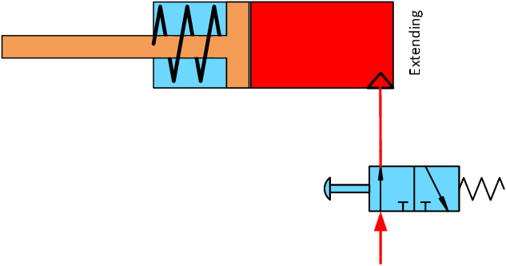
Answer:

- The operator for the end use tool pictured below has complained of lower torque and has opened the regulator to full header pressure, yet the problem still exists. Which of the yellow flag locations would be the correct measurement points to identify the problem?
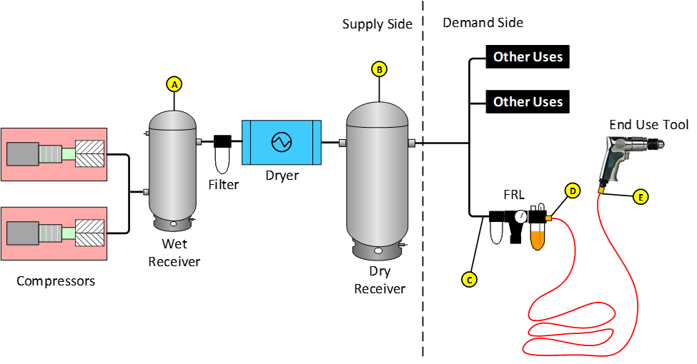

Answer:

- A demand event results in a 200 scfm airflow rate being supplied from the system's air storage volume which is 1,000 gallons. What is the pressure drawdown rate in psi/sec that will result?
Answer:

- A system operates with 100 scfm demand deficit for 30 seconds of time. If the system pressure must be no lower than 90 psig, what size receiver Is necessary?
Answer:

- What is the pneumatic capacitance of a 2000-gallon receiver at sea-level 14.7 psia? The answer should be in cubic foot/psi.
Answer:

- Use the MEASUR Tool for this one. A 55-gallon bag is placed over a leak and takes 10 minutes to fill up. What size leak is it in scfm?
Answer:

