n

Name: _____________________________________________
Company: __________________________________________
- Please prepare an inventory of compressors in your facility and complete below nameplate for each one of them. Some types of compressors are listed as below:
  - Single Acting Reciprocating
  - Double Acting Reciprocating
  - Lubricant Injected Rotary Screw
  - Lubricant Free Rotary Screw
  - Centrifugal
  - Scroll
  - Vane

Note: if you have already included the information into your block diagram, you do not have to do this assignment.
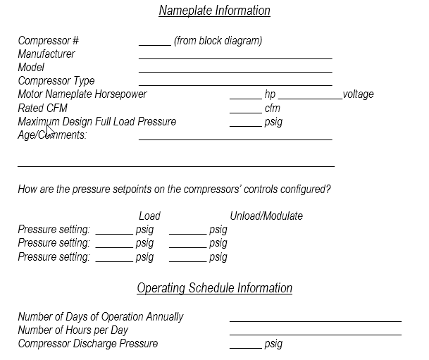

- What's the compression ratio of the single stage compressor below?
  - 13.5 psia inlet pressure
  - 113.5 discharge pressure

- List your questions about the compressors in your facilities.

