Homework #2 Pumping VINPLT
- A pump operates under the following conditions: flow is 500 gpm; suction pressure is 22.9 psig; discharge pressure is 127.4 psig; suction gauge elevation is 4 feet off the floor; discharge gauge elevation is 8 feet off of the floor; suction piping is 6 inch diameter; discharge piping is 5 inch diameter; the suction side loss coefficients total 1.75; the discharge side loss coefficients total 2.5; the fluid is corn oil with a specific gravity of 0.924. Calculate the pump head.

- Calculate the static head for the system below. Standard water is being pumped.

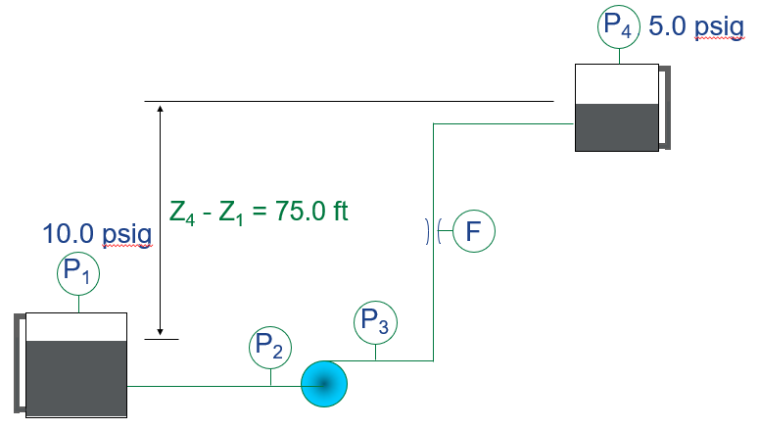

- Calculate the pump head for the figure below. The flow rate is 5000 gpm of standard water.

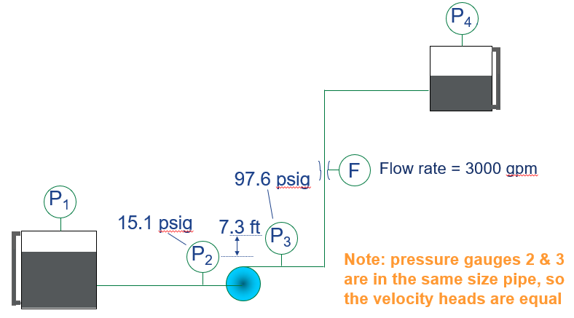

- Using the static head from Problem 2 and the pump head and flow from Problem 3, calculate the system curve this piping system. The equation should be of the form:

- A plant has a VFD installed on a 100 hp pump. The operators continue to run the pump at 60 Hz and the automatic control system is not connected to the VFD. The VFD efficiency is estimated to be 97%. How much has the operating cost for the pump increased per year if the VFD is operated at 60 Hz continuously? The average net cost of electricity is $0.08/kWh and the electric motor efficiency is 95%.

- A chilled water closed loop piping system has a 200 ton chiller with the evaporator flow at 480 gpm of water at 42 F. This piping loop has a straight pipe length of 3500 feet, 2-gate valves (wide open), 10-std 90 degree elbows, 1-check valve and 1-strainer (K = 2.0). The chiller evaporator has a 20 foot head loss and each of the 5 chilled water coils has a 12 foot head loss, all supplied by the chilled water circulating pump. Determine the following:
  - The size of the pipe need for the 480 gpm flow.
  - The total head loss for the system assuming schedule 40 black steel pipe.
  - Go to the following link and select a chilled water pump for this system. ESP Systemwize (esp-systemwize.com)
- Using the list of pumping systems developed for the first homework assignment, do the following:
  - Create a new folder for the Virtual In-plant Training.
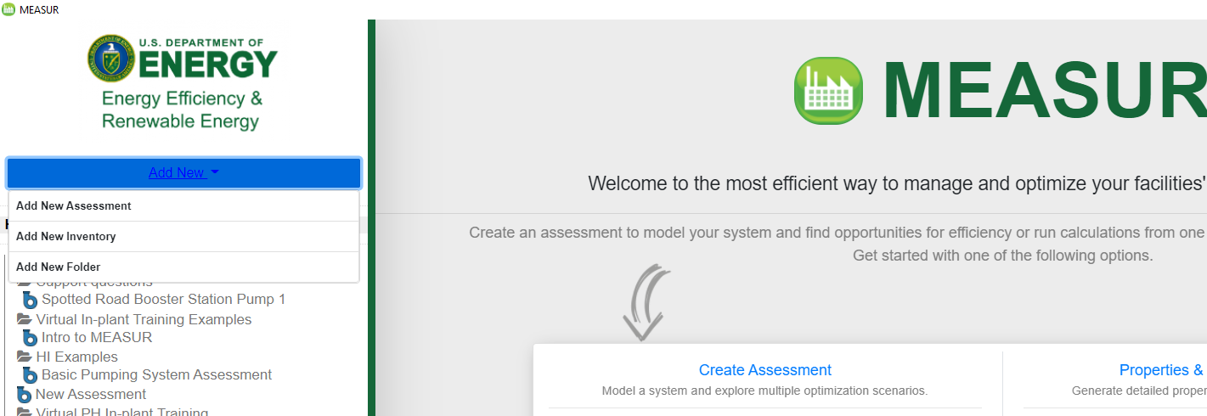

  - Create a new assessment for one of the pumps on your list.
  - When complete, select the folder content, export the assessment as a json file, and include it with your submission.
