Homework #1 Pumping VINPLT
- Using the prescreening methodology outlined below develop a list of pumping systems that you think should be examined for energy saving opportunities. Please keep in mind that one application may comprise multiple parallel pumps.

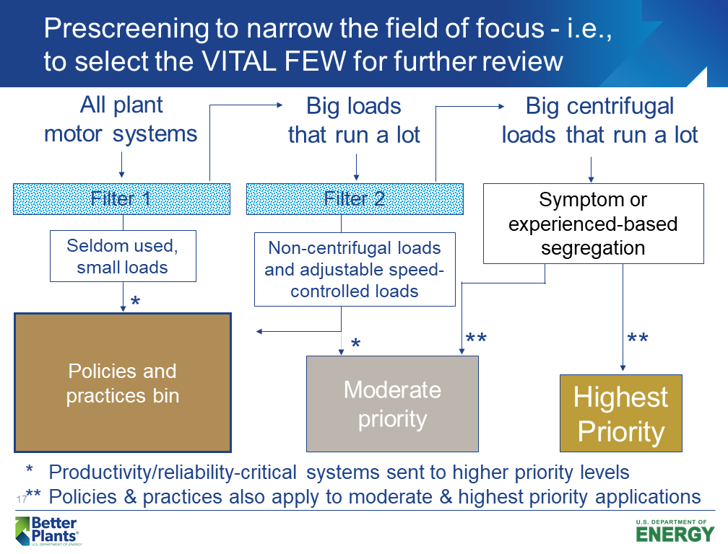

- Using the following list of symptoms of energy saving opportunities, develop a list of applications that may be opportunities for further examination. Your final list should have no more than 10 applications for consideration.
Remember, by the time the training is completed you should have a list of potential projects for implementation that you can present to your management. This is Step 1 in that process.
- If a plants net cost of electricity is $0.12/kWh and their pumps typically operate 60% of the time, what is the minimum motor size on a pump that will cost $20,000/year to operate?
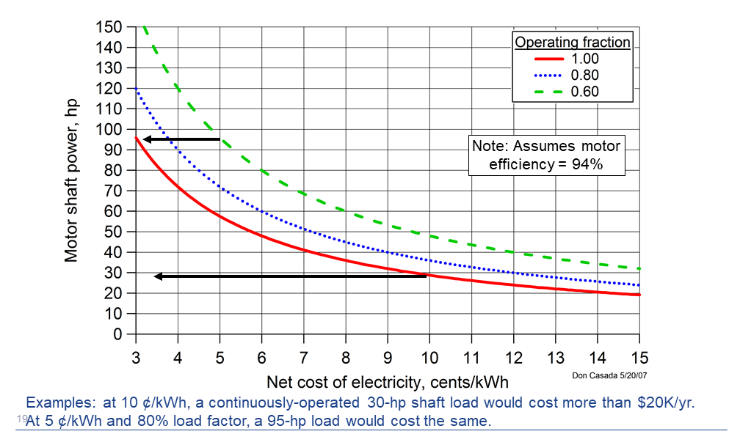

- While out in the plant you discover a pump discharge valve on a process water system that is 50% open and the flow rate is indicated as 200 gpm. Pressure gauges indicate a pressure drop across the valve of 115 psig.

a) If the pump efficiency is 72% and the motor efficiency is 92%, what is the equivalent motor input energy in kW that is being lost across the valve?

b) Repeat the above calculation assuming boiler feedwater at 250°F.

- If the boiler feedwater pump above operates all the time and the cost of electrical energy is $0.065/kWh and the demand charge if $14.75/kW-mo, how much does the energy loss across the throttled valve cost the plant per year?
If you have questions, please do not hesitate to contact us.
Glenn GCunningham@tntech.edu
Daryl coxdf@ornl.gov

Useful Equations

$hydraulic horsepower=\frac{Flow rate (gpm) ×Head (ft)×specific gravity}{3960}$ (1)

$brake horsepower=\frac{Flow rate (gpm) ×Head (ft)×specific gravity}{3960×η_{pump}}$ (2)

$electrical input horsepower=\frac{Flow rate (gpm) ×Head (ft)×specific gravity}{3960×η_{pump}×η_{motor}}$ (3)

$Head=\frac{2.31×P}{specific gravity}$ (4)

At standard conditions

